Curriculum Vitae
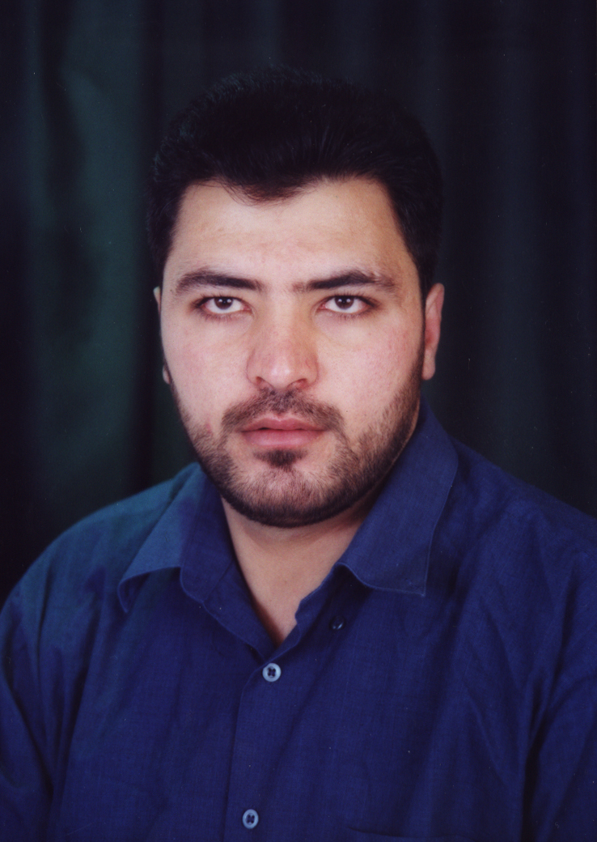
PERSONAL INFORMATION

Name: Ayman Mustafa Hussein Dabbagh
Place of Birth: Bethlehem, Palestine
Date of Birth: January - 13 1976
Religion: Islam
Nationality: Palestinian
Marital Status: Married, 4 children
Address: Ramallah, Palestine
Phone: 0097 02 2974906
Mobile: 0097 059 7195337
E-mail: aymandabbagh1976@gmail.com

EDUCATION
Years | Certificate | Domain | Average & Grade | Thesis Title | Academic Establishment
200- 2003  Amman, Jordan | Ph.D. | Islamic Jurisprudence and its Fundamentals. | (3.81/4) Excellent | The Theory of Incomes Distribution Upon Production Factors In the Islamic Jurisprudence (a comparative study) | Faculty of Shari’a,  Jordan University
1997- 2000  Amman, Jordan | M.A | Islamic Jurisprudence and its Fundamentals. | (3.87/4) Excellent | The Appropriateness Path at Imam Abi Hamid Al-Ghazali and the Fundamentalists (a comparative study) | Faculty of Shari’a,  Jordan University
1994- 1997  Amman, Jordan | B.A | Islamic Jurisprudence and its Fundamentals. | (3.81/4) Excellent  Rate: The first |  | Faculty of Shari’a,  Jordan University.
1993 –1994  Ramallah, Palestine | High school | Scientific Branch | (93%) Excellent |  | Hashemite School,

Professional Ranks
Rank | Period
Associate Professor | (2019 – till now)
Assistant Professor | (2004 – 2019)

Teaching areas and research interest
Jurisprudence of Financial Transactions
Islamic Finance and Islamic Economics
Fundamentals of Islamic Jurisprudence

Employment History
Years | Domain | Establishment
(20) years  (September 2004 – up to now)  Nablus, Palestine | University Teaching  teaching Islamic jurisprudence and its fundamentals courses,  especially financial jurisprudence and Islamic finance courses, such as: Sources of obligations, Real and collateral liabilities, Companies and commercial contracts, Nominate contracts, Jurisprudence of contemporary financial transactions, Jurisprudence of financial markets, Zakat economics and contemporary applications, Investment and finance in Islam, Principles of the economic system in Islam,  and Jurisprudence Fundamentals courses, such as:  Semantics, Analogy, and Objectives of Islamic law.  and other Jurisprudence courses, such as:  Jurisprudence of prayer and fasting, Jurisprudence of zakat and Hajj, Jurisprudence of marriage and divorce, Jurisprudence of crimes, Political jurisprudence. | Faculty of Shari’a,  An-najah National University
(9) years  (August 2010 – July 2016)  (August 2017 – July 2018)  (August 2020 – till now)  Nablus, Palestine | Head of Islamic Banking Department | Faculty of Shari’a,  An-najah National University

RESEARCHES
Research Title | Journal | Publishing Information
(1) Shari`ah Governance in Contemporary Islamic Financial Institutions | International Islamic Fiqh Academy | Accepted for Publication  Date of acceptance  16/7/2024
(2) The Prophet Muhammad (peace be upon him) intenion to appoint Abu Bakr (may Allah be pleased with him) as a Successor to the Muslims but did not carry out this Intention: Indications and objectives (Joint Research) | Arab Journal for Scientific Publishing. Issued by: research and development for Human Resource Remmah-Jordan center | Issue (98), January, 2025 AD, pages (329-350).
(3) A stipulation of a lump sum return for the partner: its cases, forms, and provisions: A comparative jurisprudential study | Journal of Umm Al-Qura University (UQU) for Shari`ah Sciences and Islamic Studies, Umm Al-Qura University, Mecca, Saudi Arabia | Issue (98), September, 2024 AD, pages (110-129).
(4) Repurchase what he sold for less than what he sold before cashing the first price according to the Hanafis Jurisprudence | Al Meezan Magazine  for Law and Islamic Studies  The World Islamic Sciences and Education University W.I.S.E  Amman, Jordan | Volume (11), Issue (2), 2024 AD, pages (255-288).
(5)The credit card of murabaha & Ijarah (leasing) of benefits and services in the Palestinian Islamic Bank (critical & analaytical jurisprudential study) | Jordan Journal Of Islamic Studies, Al-Bayt niversity Mafraq, Jordan | Volume (20), Issue (1), 2024 AD, pages (227-260).
(6) Ceiling the Profit of the Sukuk Holders that are managed through Agency by a Lump Sum to grant the surplus to the agent | IUG Journal of Sharia and Law Studies  Peer-reviewed Journal of Islamic University-Gaza, Palestine | Volume (31), Issue (4), 2023 AD, pages (92-112).
(7) Ceiling the Profit of Some Partners with a Lump Sum: its Reality, its Applications in Islamic Finance Institutions, and its Judgement | journal of scientific research and islamic studies, Faculty of Islamic Sciences, Algeria University, Algeria | Volume (15), Issue (4), 2023 AD, pages (81-108).
(8) The Similarity of Genus: Is It a Part of Usury of Excess Cause or a Condition? | Journal of Contemporary Fiqh Research, Riyadh, Saudi Arabia. | Year (35), Issue (122), Safar, 1445 AH, August, 2023 AD, Pages (439-521).
(9) The extent to which the Hadith of the dates of Khaybar indicates the permissibility of selling and repurchasing with the same person | International Journal of specialized Islamic Studies, Amman, Jordan | Volume (8), Issue (3), 2023 AD, pages (100-112).
(10)The Impact of the Difference of Religion on the Rule of Gift Contract in Islamic Jurisprudence (Joint research) | International Academic Journal for Islamic Studies, Amman, Jordan | Volume (4), Issue (1), 2022 AD, pages (1-25).
(11) Islam Jurists' Opinions in what so-called "Assalam Alhall": Comparative Jurisprudential study | Journal of Contemporary Fiqh Research, Riyadh, Saudi Arabia. | Year (30), Issue (113), Jumadul Awal, 1440 AH, February, 2019 AD, Pages (327-400).
(12) Shari'a Criteria for Distribution of Loss and Profit Ratios in the Company's Memorandum of Association: Comparative Jurisprudence Study | Jordan Journal  Of Islamic Studies  Al-Bayt University  Mafraq, Jordan | Volume (15), Issue (1), 1440 AH, 2019 AD, pages (103-136).
(13) Prohibition of ‘Qafeiz At-Tahhan’: Hadith Proveness Study | Al Mezan Magazine  For Islamic legal studies  The World Islamic Sciences and Education University W.I.S.E  Amman, Jordan | Volume (5), Issue (2), Ramadan, 1439AH, June, 2018AD, pages (311-339).
(14) Seller's Privilege on Sales and the Islamic Legislative Miracle therein  Comparative Jurisprudence and Legitimate Study | Jordan Journal  Of Islamic Studies  Al-Bayt University Mafraq, Jordan | Volume (14), Issue (2), 1439AH, 2018AD, pages (9-28).
(15) Exchange of Monetary Debts: Comparative Jurisprudential Perspective | Journal of Sharia & Law  U.A.E University  Al-Ain, U.A.E | Year (30), Issue (68), October, 2016, Pages (79-129).
(16) Islamic Opinion of Selling Gold for Deferred Banknotes: contemporary jurisprudence perspective | Journal of Shari’a and Islamic Studies  Scientific Publishing Council - Kuwait University  Kuwait | Year (30), Issue (102), September, 2015, Pages (305-362).
(17) Legitimacy of Contracting Session’s Option: (New Envision) | Journal of Al-Quds Open University for Research and Studies  Al-Quds Open University  Palestine | Volume (35), Issue (2), February, 2015, Pages (241-285).
(18) Abuse in Divorce: its Reality, Criteria, Cases, and Sanctions | Al-Aqsa University Journal (Humanities Series)  Al-Aqsa University  Gaza, Palestine | Volume (18), Issue (1), January, 2014, Pages (63-101).
(19) The Contemporary Islam Jurists' Approach in Dealing with the “Exceptional Circumstances Theory”: Analysis and Criticism | An-Najah University Journal for Research - B (Humanities)  An-najah National University  Nablus, Palestine | Volume (28), Issue (7), 2014, Pages (1665-1704).
(20) Human freedom in Islamic politics | Islamiyat al Marifah  International Institute of Islamic Thought  Herndon, VA, USA  Amman, Jordan | Year (19), Issue (75), Winter, 2014, Pages (43-81).
(21) The Islamic jurisprudence fundamentalists methods in the question of Islamic laws rationalism (Joint research) | Dirasat  University of Jordan  Amman, Jordan | Volume (32), Issue (1), 2005, Pages (174-195).

BOOKS
Title | Date | Description
The Appropriateness Path at Imam Abi Hamid Al-Ghazali and the Fundamentalists (a comparative study) | June, 2000 | M.A thesis
The Theory of Incomes Distribution Upon Production Factors In the Islamic Jurisprudence (a comparative study) | June, 2003 | Ph.D. thesis
The Islamic Culture | 2010  Nablus, Palestine | supervising and participating with others in composing (co-auther).  A book decided as a reference to be studied by all students of An-najah University, Nablus, Palestine

Membership in scientific committees
Years | Domain | Establishment
(4) years  (September 2020 – till now) | Membership in Ifta’a Committee of Faculty of Shari’a Ifta’a site | Faculty of Shari’a,  An-najah National University
(13) years  (2011– till now) | Membership of Preparation Committee & Scientific Committee  for annual conferences | Faculty of Shari’a,  An-najah National University
(2) years  (May 2018 – May 2020) | Membership of Ifta’a & Islamic Supervision Committee | Arab Islamic Bank  Palestine
(1) year  (2010-2011)  Nablus, Palestine | supervising and participating with others in composing (co-auther) of a book titled (Islamic Culture).  A book decided as a reference to be studied by all students of An-najah University, Nablus, Palestine | Faculty of Shari’a,  An-najah National University
(1.5) years  (January 2005 – June 2006)  Ramallah, Palestine | Membership of the National Palestinian Team, to compose the Palestinian curriculum in Islamic Education for Tawjeehi (high school) | Ministry of Education, Palestine

Academic development and quality of teaching
Period & Place | Title | Kind of Participation | Organizer
28 October-1 november 2020  Dubai, UAI | Certificate of “Certified Islamic Arbitrator and Expert” | Attending an intensive training course of (32) training hours + taking a written exam | The International Islamic Centre for Reconciliation and Arbitration (IICRA)
19–27 July, 2011  Nablus, Palestine | Seminar for Excellence in Teaching (SET)  Under the leadership of a team from North Western University in USA | Participation+ Training | AMIDEAST & North Western University in USA & An-najah university
26–27 march, 2011  Caesars Hotel  Ramallah, Palestine | Seminar for Excellence in Teaching (SET) | Participation+ Training | AMIDEAST
2–3 Mars, 2009  Nablus, Palestine  Jenin, Palestine | Intended Learning Outcomes (ILOs)  Under the leadership of: prof. Robert Scofield, British Council, Jerusalem | Participation+ Training | An-najah National University, Nablus, Palestine.  Arab American University, Jenin, Palestine.

Workshops
Period & Place | Title | Kind of Participation | Organizer
6 February, 2018  Grand Park Hotel  Ramallah, Palestine | Family terms between reality and hope: Islamic and legal dialogue | Participation+ with a paper titled: "Watching the child under custody: A new Islamic Perspective considering Islam legislation objectives" | Office of the Chief Justice, Palestinian Authority  & Sawasiya Program, UN
31 May–02 June, 2010  Amman, Jordan | International Human rights Law (IHL)  Under the leadership of: prof. Ameur Zemmali | Participation+ with a paper titled: (The Humanitarian Base of International Relationships According To Islam) | International Committee of the Red Cross (ICRC)
Scientific forums | Many topics | Participation in speech and dialogue
media | Many topics | Participation in speech and dialogue

CONFERENCES
Period & Place | Title | Kind of Participation | Organizer
26 April 2018  An-najah National University  Nablus, Palestine | Islamic banking in Palestine / between reality and hope | Participation  +Membership of Preparation Committee & Scientific Committee | Faculty of Shari’a  An-najah National University  Nablus, Palestine
20 September 2017  An-najah National University  Nablus, Palestine | Islamic Sciences education and ways to develop | Participation  +Membership of Preparation Committee & Scientific Committee | Faculty of Shari’a  An-najah National University  Nablus, Palestine
24 Mars 2016  An-najah National University  Nablus, Palestine | Drug abuse: causes, effects and treatment / from an Islamic, social and legal perspective | Participation  +Membership of Preparation Committee & Scientific Committee | Faculty of Shari’a  An-najah National University  Nablus, Palestine
30 April 2015  An-najah National University  Nablus, Palestine | Incidents of murder in society: causes and treatment / from an Islamic, social and legal perspective | Participation  +Membership of Preparation Committee & Scientific Committee | Faculty of Shari’a  An-najah National University  Nablus, Palestine
24 April 2014  An-najah National University  Nablus, Palestine | Modern means of communication and their impact on society | Participation  +Membership of Preparation Committee & Scientific Committee | Faculty of Shari’a  An-najah National University  Nablus, Palestine
25 April 2013  An-najah National University  Nablus, Palestine | Care of the elderly from an Islamic and legal perspective | Participation  +Membership of Preparation Committee & Scientific Committee | Faculty of Shari’a  An-najah National University  Nablus, Palestine
4 April 2012  An-najah National University  Nablus, Palestine | Social peace from an Islamic perspective | Participation  +Membership of Preparation Committee & Scientific Committee | Faculty of Shari’a  An-najah National University  Nablus, Palestine
28 April 2011  An-najah National University  Nablus, Palestine | Zakat for employees and free professions | Participation  +Membership of Preparation Committee & Scientific Committee | Faculty of Shari’a  An-najah National University  Nablus, Palestine
14 June, 2010  Ramallah, Palestine | The Islamic Banks In Palestine: The Status Que and the Challenges | Participation+ with a paper titled: "The Role of Islamic Banks In Eliminating Financial And Banks Crisis" | Ministry of Education, Palestinian Authority

LANGUAGES
Language | Reading | Writing | Conversation
Arabic | Mother language
English | Excellent | Excellent | Very good

SKILLS & HOBBIES
Reading books.
Writing scientific researches.
Sport.

