Curriculum Vitae
A- Personal Information:

Name: Ghaleb
Family Name: Adwan
Place of Birth: Tulkarm/Faroun
Nationality: Palestinian
Marital Status: Married
Date of Birth: 11.5.1964
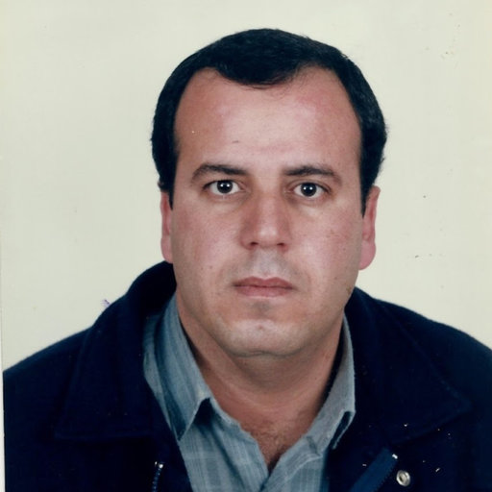

Address: An-Najah National University, Dept. of Biology and Biotechnology
Mobile: 0597-170272
E-mail: adwang@najah.edu
B- Education Record:
1. Doctoral of philosophy (Ph.D.)/ Molecular Microbiology/Molecular Virology, Department of Microbiology, School of Medicine, Aristotle University of Thessaloniki, Greece, 1999.
Thesis title: Study of genetic variations of HIV-1 virus in HIV-1/AIDS patients.
2. Master of Science (M.Sc.)/Biology with a specialization in Parasitology and Immunology, Yarmouk University, Jordan, 1990.
Thesis title: Resistance to secondary Hydatidosis: Effect of dose and type of antigen.
3. Bachelor of Science (B.Sc.)/Medical Technology, Yarmouk University, Jordan, 1987.
C- Employment Record:
1. June 1st, 2023- June 1st, 2024: American Research Foundation (Research Fellow, P00703)
2. 22/5/2023-Present: Distinguished professor
3. 2018- 21/5/2023: full professor
4. 2013: Department chairman
5. 2011- 2018: Associate Professor at An-Najah N. University
6. 2001-2011: Assistant professor at An-Najah N. University
Taught: Microbiology, Virology, General Biology I and II, Veterinary Immunology, Genetics, Applied Biotechnology I and II, Techniques in Molecular Biology, Molecular Biology for BSc. students.
Research Methods, Advanced Immunology, Advanced Parasitology, Advanced virology, Advance Microbiology for MSc. students.
Topics in Molecular Genetics and Research club in Biotechnology III for Ph.D. students.
7. 1999- 2001: An-Najah N. University and Ber Zeit University, Palestine.
*Part time lecturer.
*Taught Advanced Medical Virology, Advanced Virology, Advanced Diagnostic Parasitology, Biochemistry, Genetics and General Microbiology.
8. 1993-1995: AL-Isra University, Jordan.
*Lecturer.
*Taught General biology, Medical parasitology, Diagnostic medical parasitology and Immunology.
9. 1992-1993: Jordan University of Science and Technology, Jordan.
*Teaching assistant.
*Taught General biology
D- Experiences / Training and others:
1. Member in Medical Technology Association-Palestine
2. Member of the Board of the Faculty of Science 2004/2005
3. 1988-1990: Working in Modern Medical Laboratories, Irbid/Jordan.
4. 1986-1987: Training at Yarmouk University Laboratories.
5. Teaching assistant for one year at Yarmouk University.
6. Attended a training course on the production of Monoclonal Antibodies and their application in Parasitic Infections Yarmouk University, Irbid, Jordan, 1989.
Experiences in the following subjects:
*Molecular Biology techniques including: DNA isolation, PCR, Heteroduplex mobility assay, Molecular cloning, Transformation, Competent cells preparation, Electroporation, Agarose gel electrophoresis, DNA sequencing and Phylogenetic analysis
* Animal cell culture and isolation of viruses
* Techniques in Parasitology, serology, and Microbiology including: Electropheresis, Gel Permeation Chromatography, Affinity Chromatography, ELISA, Immunoblot technique, Immunofluorescent technique, Protein purification, and Radioimmunoassay and others.
* Bioinformatics: using CLC, MEGA software and others used in gene evolution
* Medicinal plant extracts
E- Publications (in ascending chronological order):
Homepage for publications: http://staff.najah.edu/adwang/publications
1. Papa A., Adwan G., Kouidou S., Clewiey J.P., Alexiou S., Malisiovas N., Ntoutsos I., Kiosses B., Antoniadis A. The subtypes of HIV type 1 in Greece. AIDS Research Hum Retroviruses 1998; 14: 1297-8.
2. Adwan G., Papa A., Kouidou S., Clewiey J.P., Alexiou S., Malisiovas N., Ntoutsos I., Kiosses B., Antoniadis A. HIV type 1 sequences with GGC substitution in injecting drug users in Greece. AIDS Research Hum Retroviruses 1999; 15: 679-80.
3. Papa A., Papadimitriou E., Adwan G., Clewley J.P., Malissiovas N., Ntoutsos I., Alexiou S., Antoniadis A. HIV-1 co-receptor CCR5 and CCR2 mutations among Greeks. FEMS Immunol Med Microbiol 2000; 28: 87-89
4. Adwan G., Papa A., Kouidou S., Clewiey J.P., Alexiou S., Malisiovas N., Ntoutsos I., Kiosses B., Antoniadis A. Genetic heterogeneity of HIV-1 in Greece. Microb Infect 2000; 2: 353-357.
5. Essawi T., Adwan K., Abu-Hassan N., Adwan G., Saleh A. Typing of methicillin-resistant Staphylococcus aureus by ribosome spacer and arbitrarily primed polymerase chain reaction. Turk J Med Sci 2004; 34: 5-9
6. Adwan GM., Adwan K.M. Isolation of shiga toxigenic Escherichia coli from raw beef in Palestine. Int J Food Microbiol, 2004, 97: 81-84
7. Adwan K, Abu-Hasan N, Adwan G, Jarrar N, Abu-Shanab B, Al-Masri M. Molecular epidemiology of antibiotic-resistant Escherichia coli isolated from hospitalized patients with urinary tract infections in Northern Palestine. Polish Journal of Microbiology. 2004; 53(1): 23-26.
8. Abu-Shanab B., Adwan G., Abu-Safieh D., Jarrar, N., Adwan K. Antibacterial activity of some plant extracts utilized in Palestine in popular medicine. Turk J Biol., 2004; 28: 99-102
9. Adwan G.M., Nael S. Abu-Hasan, Kamel M. Adwan, Naser R. Jarrar and Marwan M. Budair. Antimicrobial resistance of Shiga toxin-producing Escherichia coli O157 isolates from Northern Palestine. Emirates Medical Journal, 2004; 22: 249-250.
10. Adwan G, Abusafieh D, Aref R, Abo Omar J. Prevalence of microorganisms associated with intramammary Infection in cows and small ruminants in the north of Palestine. The Islamic University Journal of Gaza (Series of Natural Studies & Engineering), 2005; 13: 165-173.
11. Adwan K, Abu-Hasan N, Adwan G, Jarrar N, Abu-Shanab B, Abu-Zant A., Nosocomial infections caused by methicillin-resistant Staphylococcus aureus in Palestine. Microbial Drug Resistance. 2005; 11:75-77.
12. Abu-Shanab B., Adwan G., Abu-Safieh D., Adwan K., Abu-Shanab, M. Antibacterial activity of Rhus coriaria L. extracts growing in Palestine. The Islamic University Journal of Gaza (Series of Natural Studies & Engineering), 2005; 13, 2: 147-153.
13. Adwan K., Abu-Hasan N., Adwan G., Abu-Khater K. Hepatits B surface antibody reponse of household contacts of hepatitis B virus carriers in Palestine. Eastern Mediteranean Health Journal (EMHJ), 2005; 11: 494-498.
14. Adwan G., Abu-Shanab B., Adwan K. Enterotoxigenic Staphylococcus aureus in raw milk in the North of Palestine. Turk J of Biol., 2005; 29:229-232.
15. Adwan G. Antibiotic resistance against staphylococcal isolates recovered from subclinical mastitis in north of Palestine. The Islamic University Journal of Gaza (Series of Natural Studies & Engineering). 2006; 14: 1-9.
16. Jadallah RI, Adwan GM., Abu-Hasan NS, Adwan KM. 2005. Prevalence of hepatitis B virus markers among high risk groups in Palestine. Med J Islamic World Acad oSci 15:4, 157-160.
17. Adwan G., Abu-Shanab B., Adwan K. Jarrar N. 2006. Toxigenicity of Staphylococcus aureus Isolates from Northern Palestine. Emirates Medical Journal 24(2): 127-129
18. Abu-Shanab B., Adwan G., Jarrar N., Abu-Hijleh A., Adwan K. Antibacterial Activity of Four Plant Extracts Used in Palestine in Folkloric Medicine against Methicillin-Resistant Staphylococcus aureus. Turk J Biol 30 (2006): 195-198
19. Adwan G, Abu-Shanab B., Adwan K., Abu-Shanab F. Antibacterial effects of nutraceutical plants growing in Palestine on Pseudomonas aeruginosa. Turk J Biol 30 (2006): 239-242.
20. Abu-Shanab B., Adwan G., Adwan K., Abu-Shanab F. Efficacy of Aqueous and Ethanol Extracts of Some Palestinian Medicinal Plants for Potential Antibacterial Activity. The Islamic University Journal of Gaza, (Series of Natural Studies & Engineering),2008; 16(2): 77-86.

21. Adwan G., Abu-Shanab B., Adwan K., Odeh M. Enterotoxigenecity of S. aureus isolates recovered from chronic urogenital tract infection in North of Palestine. Pak J Med Sci., 2008, 24 (2): 246-250.
22. Adwan G, Abu-Shanab B, Adwan K. 2008. In vitro activity of certain drugs in combination with plant extracts against Staphylococcus aureus infections. Pak J Med Sci., 24: 541-544
23. Adwan G. 2009. Characterization of H5 hemagglutinin of H5N1 avian influenza virus in Middle East. The Islamic University Journal of Gaza (Series of Natural Studies & Engineering) vol 17, 47-60.
24. Adwan G, Mhanna M. 2009. Synergistic effects of plant extracts and antibiotics on Staphylococcus aureus strains isolated from clinical specimens. Asian Pacific Journal of Tropical Medicine, 2(3): 46-51
25. Adwan G, Abu-Shanab B, Odeh M. 2009. Emergence of Vancomycin-Intermediate Resistant Staphylococcus aureus in North of Palestine . Asian Pacific Journal of Tropical Medicine, 2(5):44-48
26. Adwan GM. 2009. Highly pathogenic influenza A virus (H5N1). Medical Journal of Islamic World Academy of Sciences, 17(1): 5-16
27. Adwan G, Abu-Shanab B, Adwan K. 2010. Antimicrobial activities of some plant extracts alone and in combination with different antimicrobials against multidrug-resistant Pseudomonas aeruginosa strains. Asian Pacific Journal of Tropical Medicine, 3(4): 266-269.
28. Adwan G. 2010. Molecular characterization and phylogenetic analysis of Middle East 2009 H1N1 pdm isolates. Asian Pacific Journal of Tropical Medicine, 2010; 3(8): 624-628.
29. Bdir S. Adwan G. Prevalence of intestinal parasitic infections in Jenin Governorate, Palestine: a 10-year retrospective study. Asian Pacific Journal of Tropical Medicine, 2010; 3(9): 745-747.
30. Bdir S, Adwan G. Larval Stages of Digenetic Trematodes of Melanopsis praemorsa Snails from Freshwater Bodies in Palestine. Asian Pacific Journal of Tropical Biomedicine, 2011; 200-204.
31. Adwan G, Salameh Y, Adwan K. Effect of ethanolic extract of Ecballium elaterium against Staphylococcus aureus and Candida albicans . Asian Pacific Journal of Tropical Biomedicine, 2011:456-460
32. Adwan G, Salameh Y, Adwan K. Assessment of antifungal activity of herbal and conventional toothpastes against clinical isolates of Candida albicans. Asian Pacific Journal of Tropical Biomedicine 2011; 2(5):375-379.
33. Salameh Y, Abdel Fattah M, Abu-Hijleh A, Adwan G, Jarrar N, Adwan K. 2011. Inhibitory effect of Varthemia iphionoides extract on the contractility of isolated Rabbit ileum. Journal of Pharmacy Research 2011; 4(12):4367-4368
34. Adwan G, Salameh Y, Adwan K. 2012. Susceptibility of Candida albicans isolates to Terbinafine and Ketoconazole. IUG Journal of Natural and Engineering Studies. Vol.20, No.2, pp 45-53.
35. Bdir S, Adwan G. Three new species of cercariae from Melanopsis praemorsa (L. 1758, Buccinum) snails in Al-Bathan fresh water body, Palestine. Asian Pacific Journal of Tropical Biomedicine, 2012; 2: S 1064-S 1069.
36. Bdir S, Adwan G. Three new species of cercariae from Melanopsis praemorsa (L. 1758, Buccinum) snails in Al-Bathan fresh water body, Palestine. Asian Pacific Journal of Tropical Biomedicine, 2012; 2: S 1064-S 1069.
37. Adwan K, Jarrar N, Abu-Hijleh A, Adwan G, Awwad E, Yusef Salameh Y. Molecular analysis and susceptibility patterns of methicillin-resistant Staphylococcus aureus strains causing community- and health care-associated infections in the northern region of Palestine. American Journal of Infection Control, (2013) 41: 195-198.
38. Adwan G, Adwan K, Jarrar N, Salameh Y. Prevalence of seg, seh and sei genes among clinical and nasal swab of Staphylococcus aureus isolates. Brittish Microbiology Research Journal, 2013; 3(2): 139-149
39. Adwan G, Adwan K, Bdir S, Abuseir S. Molecular characterization of Echinococcus granulosus isolated from sheep in Palestine. Exp Parasitol, 2013; 134(2):195-199.
40. Adwan K, Jarrar N, Abu-Hijleh AA, Adwan G, Awwad E. Molecular characterization of Escherichia coli isolates from patients with urinary tract infections in Palestine. J Med Microbiol. 2014. 63(Pt 2):229-234
41. Adwan G, Adwan K, Jarrar J, Amleh A. Molecular detection of nine antibiotic resistance genes in methicillin resistant Staphylococcus aureus isolates. Roum Arch Microbiol Immunol 2014;73(1-2):9-17.
42. Adwan G, Issa B, Adwan K. Virulence profile, fluoroquinolone and quinolone resistance of uropathogenic Escherichia coli isolates recovered from Thabet Hospital-Tulkarm, Palestine. British Microbiology Research Journal, 2015;5(5):412-423.
43. Adwan G, Alqarem B, Adwan K. Prevalence of foodborne pathogens in meat samples in Palestine. Int Food Res J 2015;22(5):1806-1812.
44. Adwan G, Hala Shaheen H, Adwan K, Barakat A. Molecular characterization of methicillin resistant Staphylococcus aureus isolated from hospitals environments and patients in Northern Palestine. Epidemiol Biostat Public Health 2015;12 (3), e 1 1 1 8 3
45. Adwan G, Abu Jaber A. Frequency and molecular characterization of β-lactamases producing Escherichia coli isolated from North of Palestine. Br Microbiol Res J 2016;11(5):1-13, Article no.BMRJ.22631.
46. Adwan G, Salama Y, Abu-Hasan N. Microbial contamination of environmental surfaces in An-Najah National University setting. J Sci Res Rep 2016; 10(2):1-9, Article no.JSRR.23098
47. Adwan G, Bourinee H, Othman S. Prevalence of Metallo-β-lactamases Producing Escherichia coli Isolated from North of Palestine. J Microbiol Antimicrob Agents 2016;2(1):9-15.
48. Adwan G, Issa B. Characterization of Escherichia coli isolates from patients with urinary tract infections from Thabet Hospital-Tulkarm, Palestine. An-Najah Univ J Res - Nat Sci 2016;30:31-52.
49. Adwan G, Rabaya D. Prevalence and molecular characterization of β-lactamases in clinical isolates of Klebsiella pneumoniae from North of Palestine. Int J Curr Res 2016;8(3): 28058-28067.
50. Adwan G, Abu Hasan N, Sabra I, Sabra D, Al-butmah S, Odeh S, Abd Albake Z, Badran H. Detection of bacterial pathogens in surgical site infections and their antibiotic sensitivity profile. Int J Med Res Health Sci 2016;5(5):75-82.
51. Adwan G, Bourinee H. Molecular characterization of some new E. coli strains theoretically responsible for both intestinal and extraintestinal infections. Int J Med Res Health Sci 2016, 5, 6:158-163.
52. Adwan G, Rabaya' D, Adwan K, Al-Sheboul S, Prevalence of β-lactamases in clinical isolates of Enterobacter cloacae in the West Bank-Palestine. Int J Med Res Health Sci 2016; 5(7): 49-59
53. Adwan G, Abedraboo E, Adwan K, Al-Sheboul S. Characterization of Indoor Air Bacterial Isolates from Rafidia Hospital, Nablus-Palestine. Arch Curr Res Int 2016; 5(3): 1-11, Article no. ACRI.29066.
54. Adwan G, Shtayah A, Adwan K, Al-Sheboul S, Othman S. Prevalence and Molecular Characterization of P. aeruginosa Isolates in the West Bank-Palestine for ESBLs, MBLs and Integrons. J Appl Life Sci Int 2016; 8(2): 1-11, Article no. JALSI.29259. DOI: 10.9734/JALSI/2016/29259
55. Adwan G, Abu Hasan N, Abubaker R, Al-Arda M. Prevalence and molecular characterization of β-lactamases among pathogens isolated from surgical site infections. J Med Pharm And Allied Sci 2016;5(11):285-301
56. Adwan G. Detection of Type III Secretion Toxins encoding-genes of Pseudomonas aeruginosa isolates in the West Bank-Palestine. J Adv Biol Biotechnol 2017;11(3): 1-10. Article no.JABB.31319.
57. Kamel Adwan, Alaa Jayousi, Sameh Abuseir, Ibrahim Abbasi, Ghaleb Adwan, Naser Jarrar. Genetic diversity of Taenia hydatigena in the northern part of the West Bank, Palestine as determined by mitochondrial DNA sequences. Acta Parasitol, 2018, 63(2), 299-303.
58. Adwan G, Haya Isayed. Prevalence and Characterization of Staphylococcus aureus Isolated from Bulk Tank Milk Dairy Cow Farms in West Bank-Palestine. Microbiol Res J Int. 2018, 23(5): 1-13.
59. Abu-Hijleh A, Adwan G, Abdat W. Biochemical and molecular evaluation of the plant Ecballium elaterium extract effects on Escherichia coli. J Adv Biol Biotechnol 2018; 19(2): 1-11.
60. Adwan GM, Abu-Hijleh AA, Bsharat NM. Antibiotic resistance and type III exotoxin encoding genes of Pseudomonas aeruginosa isolates from environmental and clinical sources in Northern West Bank-Palestine. Jordan J Biol Sci, 2019; 12(2):191-196.
61. Omar GI, Saqer MM, Adwan GM. Phylogenetic Relationship among some species of the Genera Lens, Vicia, Lathyrus and Pisum (Leguminosae) in Palestine. Jordan J Biol Sci, 2019: 12(3):289-296.
62. Ghaleb M. Adwan, Sami M. Bdir, Kamel M. Adwan. Molecular identification of two larval trematode in Melanopsis praemorsa intermediate host from the West Bank-Palestine. Pakistan J Zoo 2019; 51(6):2069-2075.
63. Hamed O, Fares O, Taleeb S, Adwan G, Saadeh H, Jodeh S. Manuel Algarra. New insights towards 1,4-Benzodiazepines from Curcumin. Design, synthesis and antimicrobial activities. Med Chem 2019;15:1-12.
64. Ghaleb Adwan. Determination of Antibiotic Resistance Profile and Virulence Genes in Escherichia coli Isolates from Palestinian Patients. Journal of Advances in Microbiology 2019; 19(1):1-9
65. Ismail SM, Adwan GM, Jarrar NR. Evaluation of Antimicrobial and Genotoxic Activity of Ephedra foeminea Ethanolic and Aqueous Extracts on Escherichia coli. Jordan J Biol Sci, 2020; 13(1):123-125.
66. Ghaleb M. Adwan, Dina M. Owda, Awni A. Abu-Hijleh. Prevalence of Capsular Polysaccharide Genes and Antibiotic Resistance Pattern of Klebsiella pneumoniae in Palestine. Jordan J Biol Sci, 2020; 13(4): 475-482
67. Sameh Abuseir, Fanny Naccache, Klaus Jung, Ghaleb Adwan, Christina Strube, Stefanie C. Becker. Genetic characterization of Asian tiger mosquito Aedes albopictus in Palestine. Bulletin of Insectology, 2020; 73 (2): 225-232.

68. Abuseir S, Abed Al-Daym M, Adwan G, Khraim N. Prevalence of Salmonella spp. in layer and broiler farms in Palestine in 2018, with special emphasis on Salmonella enterica serovar Enteritidis. Journal of the Hellenic Veterinary Medical Society, 2021; 72(1):2723-2732.
69. Adwan G, Omar G. Evaluation of antimicrobial and genotoxic potential of Capparis spinosa (L.) extracts. Microbiology Research Journal International, 2021; 31(1): 48-57.
70. Adwan G. In silico Molecular characterization and phylogenetic analysis of SARS-CoV-2 isolated in Mediterranean basin countries. Journal of Advances in Microbiology. 2021;21(4): 34-47.
71. Hamed OA, Radad R, Deghles A, Qrareya H, Dagdag O, Azzaoui K, AL Kerm R, AL Kerm R, Jodeh S, Adwan G. Design, synthesis and antimicrobial properties of cellulose-based amine film. Polym. Bull. 2022; 79: 627–641 https://doi.org/10.1007/s00289-020-03482-z.
72. Ghaleb Adwan, Ghadeer Omar. Phenotypic and Molecular characterization of fluoroquinolone resistant Pseudomonas aeruginosa isolates. Brazilian Journal of Biology, 2022;82: e239868
73. Mohamed Al-Nuri, Ibrahim Abu-Reidah, Anwar Afifi, Ghadeer Omar, Ghaleb Adwan, Ismail Warad.
GC–MS based metabolites profiling, in vitro antioxidant, antibacterial, and anti-cancer properties of different solvent extracts from leaves, stems, roots, and flowers of Micromeria fruticosa (Lamiaceae). Processes, 2022, 10, 1016. https://doi.org/10.3390/pr10051016
74. Rana Al-Kerm, Rola Al-Kerm, Othman Hamed, Ashraf Swaft, Mohammad Qneibi , Avni Berisha, Omar Dagdage, Ghaleb Adwan. Heterocylcic Based Curcumin: Design, Synthesis and Anticancer Efficacy against HeLa Cells. Sys Rev Pharm 2022; 13(5): 534-542
75. Moawiah Khatatbeh, Samir Albalas, Haitham Khatatbeh, Waleed Momani, Omar Melhem, Omar Al Omari, Zeinab Tarhini, Ashraf A’aqoulah, Mohammed Al-Jubouri, Abdulqadir Nashwan, Ghaleb Adwan, Zaid Altaany, Ayat Nashwan, Khaled Al-Waqfi, Lujain Abuirsheid, Raghad Ayasreh, Mohammed Al
Mutairi, Ala’a Al-Tammemi. Children’s Rates of COVID-19 Vaccination as Reported by Parents, Vaccine Hesitancy, and Determinants of COVID-19 Vaccine Uptake Among Children: A Multi-Country Study from the Eastern Mediterranean Region. BMC Public Health, 2022; 22(1):1375. doi: 10.1186/s12889-022-13798-2
76. Al-Kerm R, Qrareya H, Hamed O, Adwan G, Berisha A, Al-Kerm R, Dagdag O, Mazreku I, Sawafta A. Curcumin-Based Heterocycles: synthesis, antimicrobial, genotoxicity and molecular docking. Asian Journal of Chemistry, 2023; 35(4):951:960.
77. Ghaleb Adwan. In vitro assessment of antibacterial activity and potential genotoxic effect of fruit extracts of Capparis spinosa (L.) plant. Jordan Journal of Pharmaceuticals Sciences, 2023; 16(2):322-329.
78. Kholoud Thiab, Ghadeer Omar, Ghaleb Adwan, Ali Barakat. In vitro anticoagulant effect analysis of leaves different extract types of Calotropis procera (Asclepiadaceae) in West Bank/ Palestine. The Palestinian Medical and Pharmaceutical Journal (PMPJ): 2023; 8(2): 157-168.
79. Sameh Abuseir, Ghaleb Adwan, Abdelhafeed Dalab, Mohammad Altamimi, Nimer Khraim, Mohammad Abed-Aldaym, Tamara Assali. Molecular Characterization and Phylogenetic Analysis of Canine Parvovirus Isolates in Palestine. Pakistan Veterinary Journal, 2023; 43(4):677-682.
80. Adwan G, Abuseir S, Khreishi O, Hussein A, Khraim N, Abed Al-Daym M. Occurrence and molecular characterization of Salmonella Typhimurium and Salmonella Enteritidis isolates from contaminated food samples from Palestine. J Hellenic Vet Med Soc, 2023; 74(3):6201-6211
81. Ghadeer Omar, Lubna Abdallah, Ghaleb Adwan. In vitro Evaluation of Antioxidant and Antimicrobial activity of aqueous aerial parts extracts of Euphorbia helioscopia L. An-Najah University Journal for Research - A (Natural Sciences), 2024; 38(2):125-129.
82. Janem A, Omar G, Hamed O, Jodeh S, Deghles A, Berisha A, Mansour W, Abu Jabal S, Fares O, Jaser A, Amireh A, Adwan G. Water soluble curcumin with alkylsulfonate moiety: synthesis, and anticancer efficacy. Heliyon, 2024: 10: e33808. https://doi.org/10.1016/j.heliyon.2024.e33808
83. Abu Helu R, Zeer M, Adwan G. Association between Diabetes and the Outcome of COVID-19 in Bethlehem- Palestine: A Case-Control Study. Journal of Pathogens, 2024.
84. Ghaleb Adwan, Sameh Abuseir, Ghadeer Omar, Mahmoud Albzour. Molecular characterization of avian pathogenic Escherichia coli isolates recovered from broilers’ farms in northern Palestinian territories. Vet World. 2024;17(12): 2865–2879. doi: www.doi.org/10.14202/vetworld.2024.2865-2879
85. Ghaleb Adwan, Sameh Abuseir Ghadeer Omar, Heba Al-Fares, Mohammad Altamimi, Abdelhafeed Dalab, Nimer Khraim, Mohammad AbedAldaym. Molecular Characterization of Dactylopius opuntiae (Cockerell, 1896) in Palestine. Psyche: A Journal of Entomology, 2024; Vol 2024, Article ID 9986708, https://doi.org/10.1155/psyc/9986708
86. Rabaya D, Adwan G. Dysregulation and Therapeutic Targeting of RNA Splicing Variants in Cancer. An-Najah University Journal for Research - A (Natural Sciences), 2025; 39(1): accepted
87. ALqarem B, Adwan G. Novel pathogenic SNPs within MEFV gene as diagnostic markers to predict Familial Mediterranean Fever: Using in Silico analysis. Palestinian Medical and Pharmaceutical Journal, 2025;
88. Jarrar S, Adwan G. Molecular Insights: The Gut Microbiota's Impact on colorectal Cancer. An-Najah University Journal for Research - A (Natural Sciences), 2025; 39(1)
89. Samer Jarrar, Ghadeer Omar, Heba Alfares, Ghaleb Adwan. Molecular phylogenetic relationship among different species of Salvia in West Bank/Palestine. In preparation
90. Abbasi I, Abu Helu R, Abuhilal A, Adwan G. A comparison between bacterial cultivation and 16S rRNA next generation sequencing approaches for analysis of bacteria in urine and cerebrospinal fluid samples. BMC Infectious Diseases, 2024.
F- GenBank database:
1. Accession numbers: AJ224947-AJ224949, AJ224951-AJ224956, and AF094522-AF094530.
2. Accession numbers: KC109640-KC109660
3. Accession numbers: KJ544514, KJ544515, KJ544516, KJ544517, KJ544518 and KJ930035
4. Accession numbers: KJ864924- KJ864925, KJ864928- KJ864961
5. Accession numbers: KT336739-KT336757
6. Accession numbers: MF589956- MF589967
7. Accession numbers: KU594303-KU594326
8. Accession numbers: KX594822-KX594826
9. Accession number: MF589956-MF589967
10. Accession numbers: MG759487-MG759504
11. Accession number: MN062742-MN062765
12 Accession number: MN064753-MN064773
13. Accession number: MN064774- MN064783.
14. Accession number: MN064784-MN064794
15. Accession number: MN067995-MN068005
16. Accession number: MN067984- MN067994
17. Accession number: OP896841- OP896844 (ITS) Salvia
18. Accession number: OP903273- OP903278 GenBank accession OP903273-OP903278 psbA-trnH, trnL-trnF
19. Accession number: OP903279-OP903282 GenBank OP903279-OP903282 ETS
Submission ID: 2648257
17. Accession number: OQ924950- OQ924974
18. Accession number: PP939950-PP939999
19. Accession number: PP958583- PP958631
20. Accession number: PP946183-PP946229
G- Committees and others
1. Master thesis Examiner
2. Master thesis supervision
3. Participation in the assessment and evaluation of many scientific papers for different journals
4. Member of the Scientific Committee of the Council for Higher Education (2017-2019)
5. Member of the Faculty of scientific research 2016-2018 (An-Najah National Univ)
6. Member of various committees of the department, college and local society
7. Editorial board member /An-Najah University Journal for Research - A (Natural Sciences)
H- Conferences:
1. Anna Papa, G. Adwan, et al., 1997. Detection of HIV subtypes in Greece. The Greek conference of AIDS (9th).
2. A. Papa, N. Malisiovas, E. Papadimitriou, G. Adwan et al., 1998. Genetic mutations in coreceptor CCR5 among Greeks. The National conference of Microbiology (18th).
3. St. Alexiou, A. Tea, G. Adwan et al., 1998. Legionella diagnosis by Detection free antigens in urine samples. The National conference of Microbiology (18th).
4. Adwan G. et al., 1999. Characterestics of GGC sequences of V3 loop of HIV-1 genome in injecting drug users in Greece.The Greek conference of AIDS (11th).
5. MediLabSecure Project: MediLabSecure Mid-term meeting, Pasteur Institute: 15-17/12/2015
6. Ghaleb Adwan, Kamel Adwan, Naser Jarrar, Alaa Amleh. 2016. Molecular Detection of Nine Antibiotic Resistance Genes in Methicillin Resistant Staphylococcus Aureus Isolates. The 9th International Palestinian Conference of Laboratory Medicine (August 25-27, 2016). Palestine.
7. Omar G, Saqer M, Adawn G. Phylogenetic relationship among closely related species of the genera Lens, Vicia, Lathyrus and Pisum (leguminosae) in Palestine. Scientific conference “Palestinian plant genetic resources”. 21/9/2016. Palestine Technical University-Kadoorie campus.
8. MediLabSecure Project: MediLabSecure Global Conference Final Meeting, Pasteur Institute, Paris, France: held on June,25th-27th, 2018.
9. MediLabSecure Project: MediLabSecure Kick off Meeting, Pasteur Institute, Paris, France: held on July,2nd – 3rd, 2019.
10. MediLabSecure Project: MediLabSecure Regional Meeting Middle East held on May 16th -19th, Dead Sea, Jordan, 2022.
11. MediLabSecure Project: Global Meeting held in France from June 10th to 14th 2024.
Attending the scientific symposium to discuss enhancing the social and economic impact of scientific research outcomes in Palestine 29-30/5/2024
حضور الندوة العلمية لمناقشة تعزيز الأثر الاجتماعي والاقتصادي لمخرجات البحث العلمي في فلسطين 29 -30/ 5/2024
I- Languages: Arabic, English and Greek
J- Grants and research funds and rewards
1. Ph.D. scholarship from the State Scholarship Foundation (SSF), Greece.
2. Scientific Research supported by United States Agency for International Development and the Council for Scientific Research:
Title: “Detection of Enterotoxigenic Staphylococcus aureus isolates from subclinical mastitic milk in Northern Palestine”
3. Scientific Research supported by the Deanship of Scientific Research at An-Najah N. University:
Title: “Molecular characterization of Echinococcus granulosus isolated from sheep in Palestine.”
4. Scientific Research supported by Association of Arab Universities- support the Palestinian universities Fund:
Title: “A polymerase chain reaction assay for detecting snails infected with some trematodes in Palestine”
5. An-Najah National University Award- Research Excellence Award and Quality of Publication-2013
6. An-Najah National University Award- Research Excellence Award and Quality of Publication-2014
7. An-Najah National University Award- number of citations-2015
8. An-Najah National University Award- Research Excellence Award and Quality of Publication-2018
9. An-Najah National University Award- Research Excellence Award and Quality of Publication-2018
10. The Research Prize for Masters Thesis at the College of Graduate Studies for the year 2019 (2 researches).
K- Research Interest and Research in Progress:
a. Molecular diagnosis of infectious diseases including bacterial and viruses
b. Epidemiology of viral infection
c. Epidemiology of drug resistance in the bacterium and identification of resistance and virulence factors.
d. Efficacy of novel antimicrobial compounds extracted from medicinal plants
e. efficiency of newly synthesized compounds (department of chemistry) as antimicrobial agents
f. Bioinformatics
g. Parasites genotyping
L- Thesis
a. Postgraduate Students Supervision
1. Mohammad Mhanna: The In vitro interaction between plant extracts and antibiotics used on Staphylococcus aureus infections, 2008. Master thesis
2. Hala “Mohammad Shuaib” Abd Alqader Shaheen: Molecular characterization of methicillin resistant Staphylococcus aureus strains isolated from hospitals surfaces, equipments and patients in Northern Palestine, 2014. Master thesis.
3. Buthainah Ahmad Essa: Virulence factors and phylogenetic grouping in uropathogenic isolates of Escherichia coli recovered from Thabet Hospital-Tulkarm, Palestine, 2014. Master thesis.
4. Maram Saqer: Phylogenetic relationship among closely related species of the genera Lens, Vicia, Lathyrus and Pisum (Leguminosae) in Palestine. 2014. Master thesis.
5. Bara'a AL-Qarem: Polymerase chain reaction for detection of foodborne bacterial pathogens in meat products in Jenin District-Palestine. 2014. Master thesis.
6. Eman Atta Hassan Abedraboo: Characterization of indoor air bacterial isolates from hospitals in Palestine and their roles in nosocomial infection. Master thesis.
7. Douha Abu-Safeyah: Antibacterial Effects of Some Wild Allium Species in Palestine Compared with Cultivars Allium cepa and Allium sativum). Master thesis.
8. Aws Abu Jaber: Prevalence and molecular characterization of ESBL-producing Escherichia coli Isolated from North of Palestine. Master thesis.
9. Amani Shtayah: Prevalence and Molecular characterization of metallo-β-lactamases in pseudomonas aeruginosa in Nablus-Palestine. Master thesis.
10. Doa'a Rabaya': Prevalence and molecular characterization of β-lactamases in clinical isolates of Klebsiella species from North of Palestine. Master thesis.
11. Rana Hassan: Molecular phylogenetic relationship among closely related species of the clover genus (Trifolium-Leguminosae) in PalestinelWest Bank.
12. Kholoud Thiab: In vitro anticoagulation effect analysis of different extract types of Calotropis procera (Asclepediaceae) in West Bank/Palestine. Master thesis.
13. Haya Isaied: Prevalence and characterization of Staphylococcus aureus isolated from bulk tank milk dairy cow farms in West Bank-Palestine. 2017. Master thesis.
14. Wafa Abdat: Biochemical and molecular evaluation of the plant Ecballium elaterium extracts effects on Escherichia coli. 2017. Master thesis.
15. Nema Bsharat: Antibiotic resistance and molecular detection of type III secretion toxins encoding-genes in clinical and environmental isolates of Pseudomonas aeruginosa from North West Bank-Palestine. 2017. Master thesis.
16. Dena Odeh. Molecular characterization of capsular polysaccharide genes of Klebsiella pneumoniae in Palestine. 2018. Master thesis.
17. Omayma Khreishi. Molecular Characterization of Salmonella Enterica Serotype Typhimurium and Enteritidis Isolates from Food Samples in West Bank / Palestine. 2021. Master thesis.
18. Haya Radwan. Molecular characterization of Candida species isolates recovered from clinical specimens in Palestine. 2024. Ph. D. thesis
19. Mahmoud Al-Bzour. Antimicrobial resistance and molecular characterization of avian pathogenic Escherichia coli isolates recovered from broilers’ farms in northern Palestine. 2024. Master thesis
b- Internal Examiner
1. Mohammed Ibrahiem Ahmad Odeh: Biological Control of Gray Mold, Blue Mold & Rhizopus Soft Rot on Grape, Pear, Kiwi, Strawberry by Trichoderma Harzianum. 2006.
2. Esra` Madhat Mas`od Solyman: Molecular Genetic Assessment of Selected Thyme Species in Palestine Using Random Amplified Polymorphic DNA (RAPD). 2013.
3. Rinad Jalal Yahya Hamed: Phytoremediation for Treatment of Brackish Water from Reverse Osmosis Plant. 2014.
4. Maisaa Yaqoub: Intestinal Protozoa and Cryptosporidium genotypes in North of West Bank/ Palestine. 2014.
5. Nida Muthqal Daraghmeh: Management and Complications of Thalassemic Patients in Palestine: Retrospective Study. 2016.
6. Caeser M. Abu Arra: Factor VIII Intron 22 Inversion in Severe Hemophilia A patients in Palestine. 2017.
7. Rola Sultan Mahmoud AL-Kerm: Design, Synthesis, Antimicrobial and Cytotoxicity of Curcumin Based Benzodiazepines, Diazepines, Diazoles and Amines. Doctoral thesis. 2021.
8. Rania Abed Allatef : Curcumin with Schiff base functionality: synthesis and antimicrobial activities. Master thesis, 2023
9.
c. External examiner
1. May Ibrahim Mohammad Baker: Immunological detection of Anti-nuclear antibodies (ANA) using continuous cell lines and DNA rich non-pathogenic organism. Al-Quds University, 2016.
2. Hiba Najeh Yassen Milhem: Molecular Characterization and Antibiogram of Pseudomonas aeruginosa Isolated from Postsurgical Infections. Al-Quds University, 2016.
3. Dua’a Salim Abdullah Ja’fari: Detection of Biofilm Formation Among Clinical Isolates of Enterococcus and Their Antibiotic Susceptibility Pattern. Al-Quds University, 2018.
4. Hind Abdo. Prevalence of Salmonella spp. and Shiga-Toxin Producing E. coli (STEC) among Living Poultry in Tulkarm by Culture and PCR. Palestine Technical University, 2019.
5. Ayah Ibrahim Abd-Elhameed “Mohammad Ahmad”: Identification of Dermatophyte Species by PCR Restriction Fragment Length Polymorphism in Ramallah region, Palestine. 2021. Al-Quds University/ Palestine .
6. Dana Naim Jabra Sam’an. Detection of Extended Spectrum Beta Lactamases (ESBL) production in Pseudomonas aeruginosa from various clinical samples. 2022. Al-Quds University/ Palestine.
M. Homepages
https://staff.najah.edu/ar/cpanel/scientific-research/published-research/
https://staff.najah.edu/en/profiles/2372/
https://www.researchgate.net/profile/Ghaleb_Adwan
https://www.linkedin.com/home?trk=nav_responsive_tab_home
https://independent.academia.edu/Gadwan
https://scholar.google.com/citations?user=&user=2wFQo38AAAAJ
N. ORCID ID:
https://orcid.org/0000-0002-0335-0140
O. Scopus Author Identifier: 8205770600
P. Index
Scopus: H-index 15
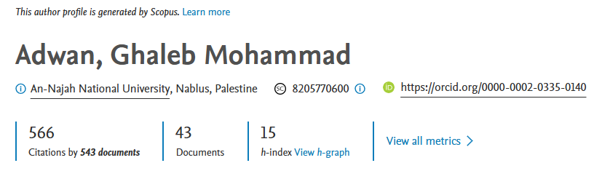

Google Scholar: H-index 24, i10-index 43 (AD Scientific Index ID: 336204

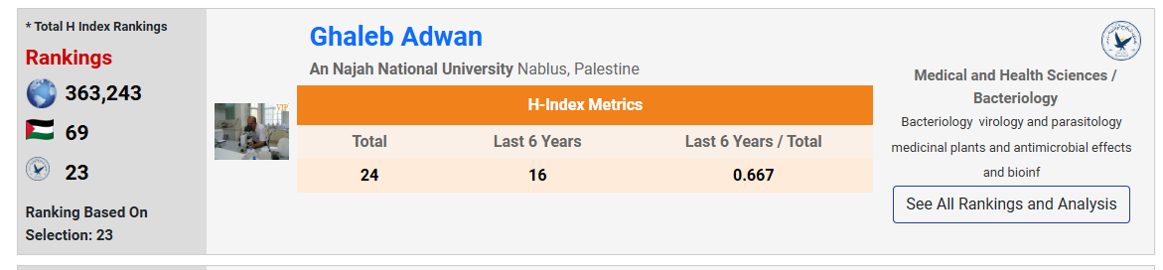

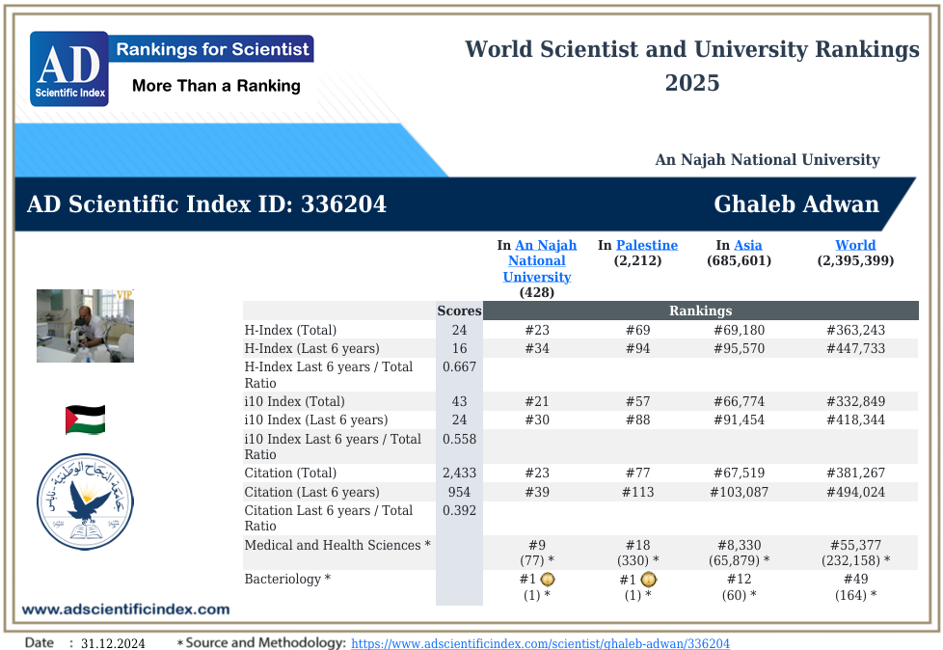

Q. American Research Foundation (Research Fellow)
