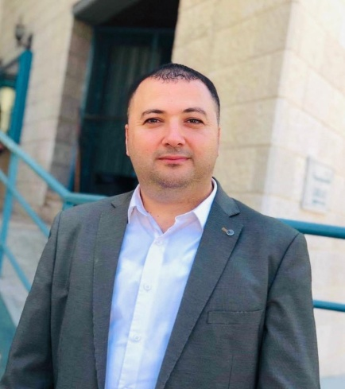 | Asaad Zuhair Taffal  PhD in Social Sciences (International Relations)  BA and MA in Sociology
CONTACT  Address  Nablus, Palestine  Phone number  0599 799 371  Email  as3ad_taffal@najah.edu  as3ad_taffal@yahoo.com  SKILLS  - Tact and diplomacy.  - The ability to work under pressure and within a team.  - The ability to finish duties within a limited time frame.  - The ability to work in a leading position.  - Creativity is a concern.  LANGUAGES  Arabic: Excellent  English: Very good  French: Basic  Hebrew: Basic  Polish: Basic | PROFESSIONAL EXPERIENCE and achievements  Member of the founding committee of the Youth Reflections Association Creativity.  April 2024  Member of a committee to prepare the annual report on the university’s efforts to achieve the Sustainable Development Goals (SDGs).  March 2024  Certificate of Moodle Teaching with AI from the E-Learning Center.  October 2023  Supervising the signing of a memorandum of understanding with the Department of Refugee Affairs in the Palestine Liberation Organization (PLO) regarding the master's program of Migration and Refugee Studies.  April 2023  Member of the General Union of Palestinian Historians and Archaeologists.  April 2023 – Present  Signing a memorandum of understanding with the official responsible for the Palestinian immigration file in the European Union as part of the development of the “Master’s in Migration and Refugee Studies” program.  December 2022  Certificate of Ambassadorship from The UN Refugee Agency-UNHCR.  November 2022  Participation in the arbitration and evaluation committees during the twenty-third creative student forum of the Association of Arab Universities, which was held at Al-Zaytoonah University of Jordan.  November 2022  Head of master's Program in Migration and Refugee Studies at An-Najah National University, Nablus, Palestine.  August 2022 - Present  Head of the Department of Social Work at An-Najah National University, Nablus, Palestine.  August 2019-August 2023  Certificate as an expert at Najah Startups for Social Good Affiliated with The Safir EU Project.  July 2022  Obtaining an advanced training course in the field of competency-based learning, project learning, problem learning, training and enhancing student participation through group work.  May 2022  An important scientific visit to Arizona State University (ASU) in the United States of America to exchange experiences and knowledge on the subject of social entrepreneurship, especially in the humanities and social sciences.  May 2022  Winning the title of a social influencer in Palestine by spreading optimism, positive energy, and social support among young people through lectures, media meetings, and social media.  December 2021  Obtaining a scholarship from the Erasmus+ Program of the European Union to teach a group of European students and researchers about political and social changes in the Middle East.  March 2019  Annual participation in the international conference (Beyond Europe: Toward a New Global Order).  December 2017-present  PhD in International Relations from Adam Mickiewicz University in Poznan- Poland.  December 2016  My thesis was entitled(Erosion ofthe collective memory  on the example ofPalestinianrefugees in the West Bank).  Member in the Quality Assurance Unit at the faculty of Arts at An-Najah National University, Nablus, Palestine.  September 2010-July 2013  Assistant Head of the Department of Sociology and Social Work at An-Najah National University, Nablus, Palestine.  September 2010-July 2013  Member in the Quality Assurance Unit at the Department of Sociology and Social Work, An-Najah National University, Nablus, Palestine.  October 2010-Present  Get a full scholarship to study a doctoral degree in Polandwithin the EPIC project of the Erasmus Mundus program in the EU.  July 2013  Part-time lecturer at the Department of Social Work at Al-Quds Open University, Nablus, Palestine.  October 2007-July 2009  Member in the Department of Sociology and Social Work, An-Najah National University-Nablus-Palestine.  September 2006- Present  EDUCATION  PhD Degree in International Relations, Adam Mickiewicz University, Poznan, Poland.  2013-2016  Master Degree in Sociology, Birzeit University, Birzeit, Palestine.  2002-2005  My thesis was entitled(The role of women in decision-making within the Palestinian family).  Bachelor Degree in Sociology and Anthropolgy, Birzeit University, Birzeit, Palestine.  1998-2002  PUBLICATIONS____________________________________  - March 2023: Difficulties faced by Palestinian refugee women in Nablus camps.  - December 2021: Students' Readiness to Succeed and Persist in Their University Study.  - January 2019:Europe and the Syrian Refugees: Challenges and Opportunities of a Dilemma.  - January 2018: Collective Memory: A Universal Phenomenon-The  Palestinian Collective Memory as a Case Study.  - June 2017: The Impact of the Arab Spring on the Palestinian Question.  - November 2016: Poland and Palestine – Contemporary Relations.

