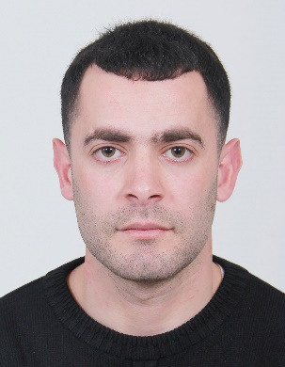**SHADI Imad Ali QADDUMI**

**Phone**: (+972) 594311579

**Email address:** shadi.qaddumi@najah.com



**Address:** Nablus, Palestine.



**Academic Qualifications**

* PhD Degree (2019) in Islamic law, Sakarya University, Sakarya, Turkey.

**Title of Thesis**: Benefit-motivated justification in the Hanafi school of Jurisprudence (The sample of Bada'I Al-Sana'i).

* Master Degree (2015) in Islamic law, Al-Najah National University, Nablus, Palestine.

**Title of thesis**: Contemporary Harmful Commodities to Human Health: An Islamic Jurisprudential Study.

* Bachelor Degree (2009) in Sharia and Islamic Banking, Al-Najah National University, Nablus, Palestine.

**Courses and Certificates obtained**

* Course in Comprehensive accounting program.
* Course in English Language, Palestine (2010-2012), England (2012).
* Course in Turkish Language, Sakarya, Turkey (2015-2016).
* Certificate in "Tajweed of Quran"
* Certificate in memorizing the Holy Quran.

**Publications**

* [The Change in Abu Yusuf and Imam Muhammad’s Ijtihads Related to Judgement (Reasons- Resources– Analysis)](https://staff.najah.edu/en/publications/14732/)**,** Journal of Academic Research in Religious Sciences. (2019)
* [The Change in Abu Yusuf’s Ijtihads Related to Worships (Reasons- Resources– Analysis)](https://staff.najah.edu/en/publications/14731/) Journal of Divinity Faculty of Hitit University. (2018) (Prof. dr. Soner DUMAN& Dr. Shadi QADDUMI).
* [Juristic Adaptation of the will to donate to the human organ](https://staff.najah.edu/en/publications/14733/). Journal of Al-shihab. (2018).

**Professional Experiences**

* Assistant Professor in the Faculty of Sharia at Al-Najah National University (Nablus, Palestine) from 2021 until now.
* Imam and preacher at the ministry of awqaf and religious affairs from 2010 until now.
* Head of preaching and Guidance Department at Ministry of awqaf and Religious Affairs (2023).

**Languages**

* Arabic mother language.
* English (Level B2)
* Turkish (Level C1).

**References**

* Prof.Dr. Soner DUMAN, Sakarya University, the faculty of theology. (0505-4782595).
* Prof.Dr. Osman GüMAN, Sakarya University, the faculty of theology. (0505-3949134).
* Recep Kılıç, sakarya university, [Department of Mechanical Engineering. (0533-4704038)](https://www.researchgate.net/institution/Sakarya_University?_tp=eyJjb250ZXh0Ijp7ImZpcnN0UGFnZSI6InB1YmxpY2F0aW9uIiwicGFnZSI6InByb2ZpbGUifX0)
* Erol DEMIR, the imam of Sakarya University's Mosque. (0532-5438067).