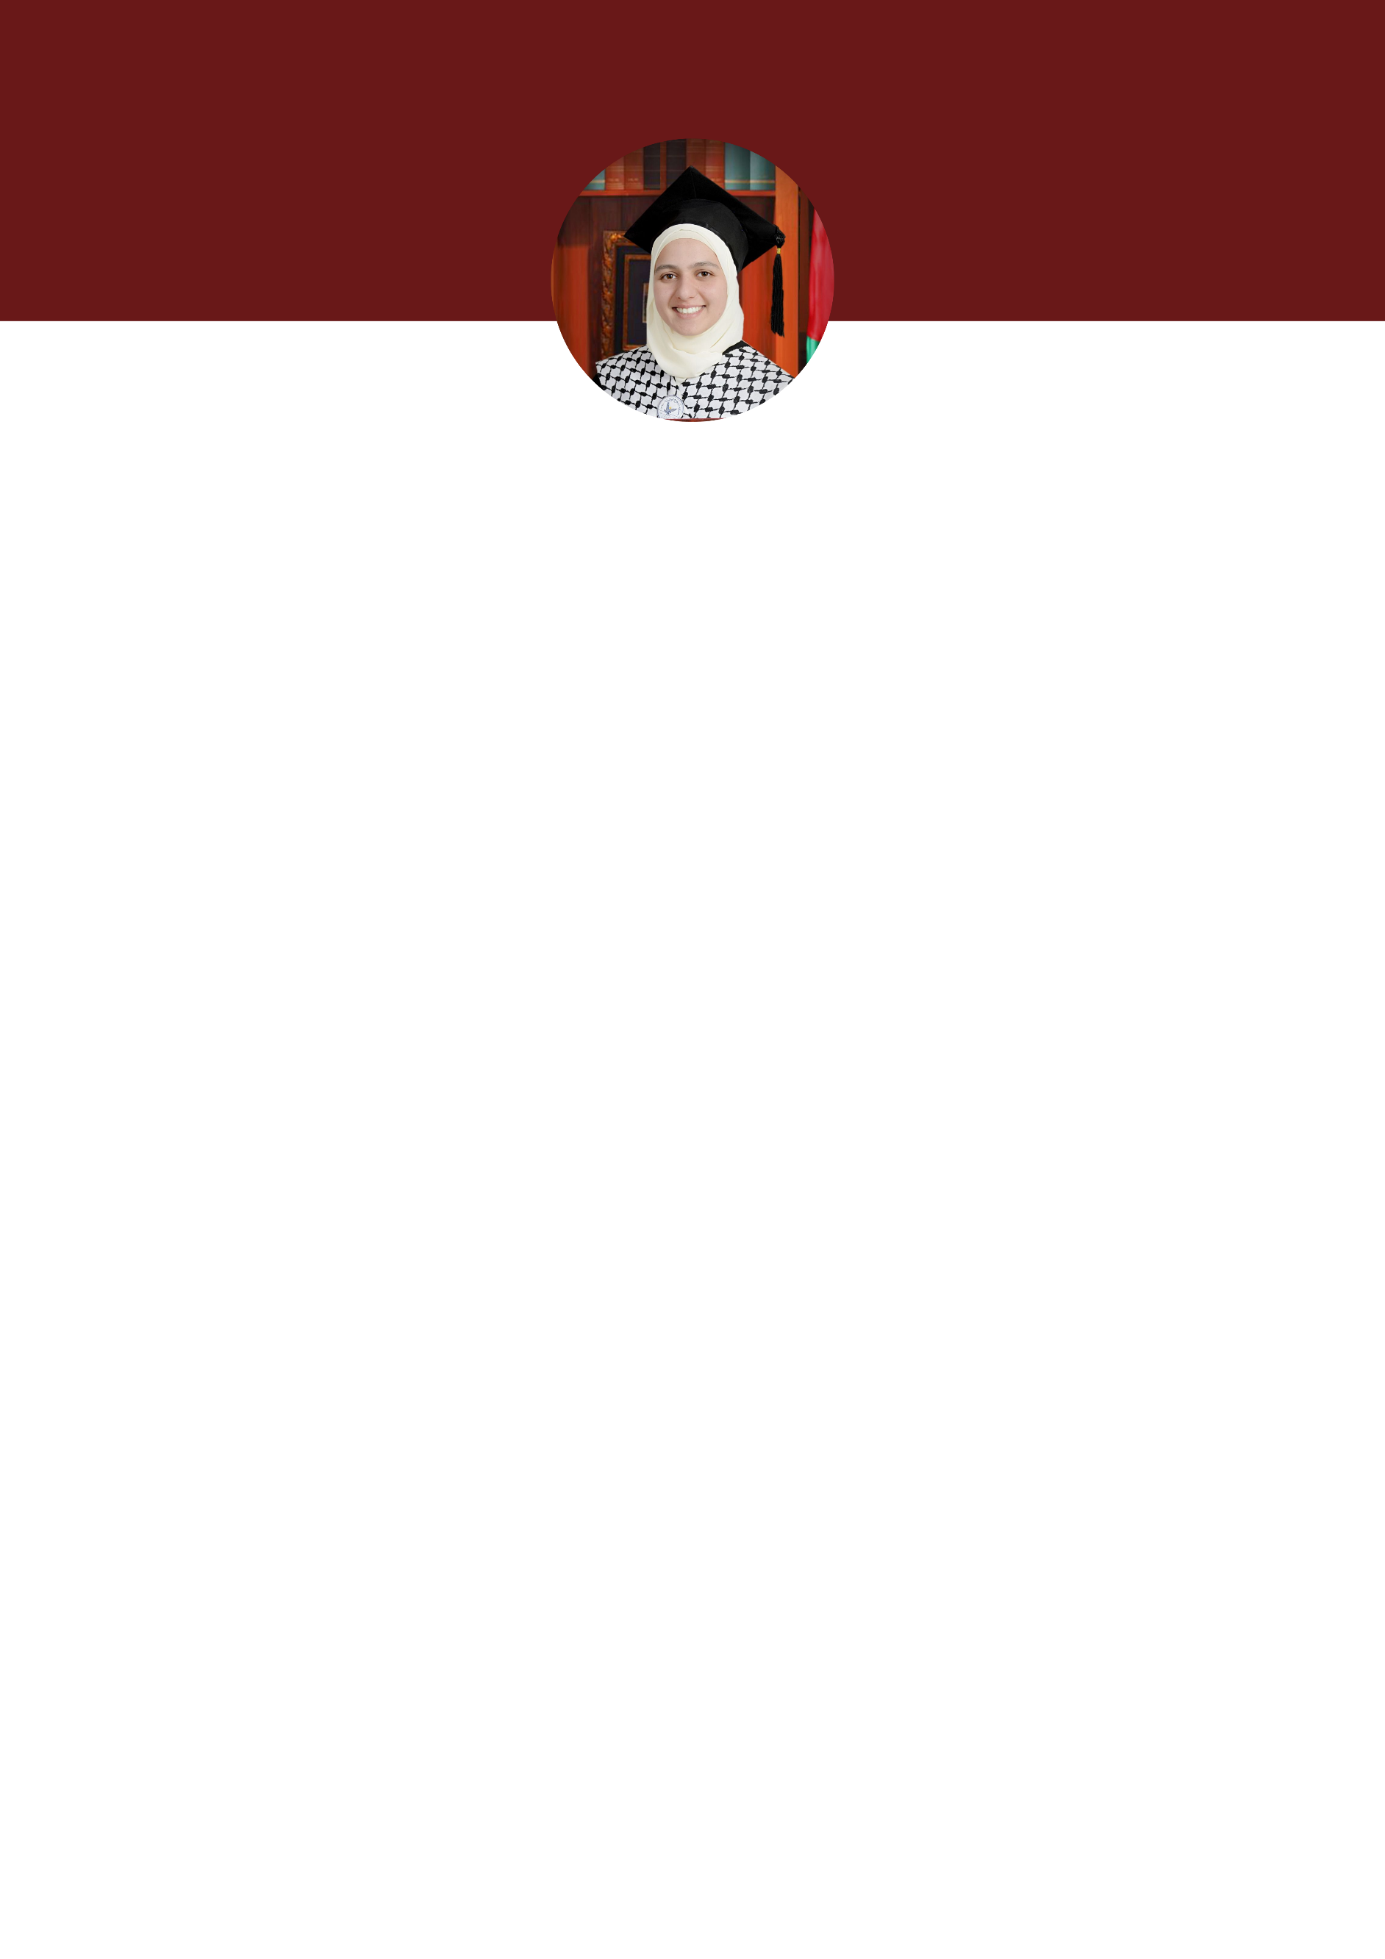

Suhaila Sufyan Abdel Karim Ghannam

Personal Information
- Phone number 00972597531820
- Email suhaila.ghanem@najah.edu
- Address Beitin- Ramallah
- Date of birth 17th- Feb-2001

Academic Qualifications
- Aug 2022-present
Master's Degree in Religion Fundamentals, the Faculty of Higher Education, An-Najah National University, Nablus, Palestine. (GPA 4)
- Aug 2018-Jun 2022
BA in Religion Fundamentals, the Faculty of Shari' a, An-Najah National University, Nablus, Palestine. (GPA 4)
- Aug 2017-Jun 2018
GCSEs in the scientific branch of Islamic Secondary Girls' School, Al-Bireh.
Average 97.4

Languages
- Arabic language: Native.
- English Level B1 (Writing, Reading and Speaking)

Skills and abilities
- Good Communication Skills.
- Time and Self-Management
- Ability to work under pressure
- Ability to work within a team
- Having distinctive listening and communication skills.
- Modern and creative teaching skills.
- Computer entry skills.
- Constructive thinking to solve problems at work.
- Flexibility in the working environment.
- Computer Skills
Microsoft Office Program (Word, PowerPoint and Excel), Google Drive

Training Courses
- 2022
Reading according to Qalun’s narration and reading by Ibn Katheer and Abu Jaafar with a chain of narrators connected to the unseen.
- 2020
Ijaza with the chain of transmission related in absentia to the readings of Asem and Yaqoub via Al-Shatibiyyah and Al-Durrah, and to the narration of Hafs on the authority of Asim via Al-Misbah.
- 2019
Course in Qur’anic Sciences, Noon Center, Al-Bireh.
- 2017
Ijaza of Al-Jazariyah (a 118- line poem where all of the Tajweed rules are explained).
- 2015
Advanced Tajweed course.
- 2015
A beginner Hebrew language course affiliated with the Cultural Committee in the Municipality of Al-Bireh.
- 2012
A course in summarizing and discussing books affiliated with the Tamer Foundation for Community Education.
- 2011
Beginner Tajweed course affiliated with the Ministry of Awqaf.

Voluntary work
- 2022
Volunteering in memorizing the Qur’an at the Al-Bireh Academy for the Qur’an and its Sciences, affiliated with the Ramallah Endowments Directorate.
- 2018-2022
Supervision of the Holy Qur’an Forum, affiliated with the College of Sharia and the Deanship of Student Affairs, An-Najah National University.
- 2019-2020
Volunteering in the activities committee at the Faculty of Sharia at An-Najah National University.
An initiative of weekly interpretation meetings in person in the village of Beitin.

Work Experience
- Aug 2022-present.
A Part Time teacher at An-Najah National University in the Faculty of Sharia, Hisham Hijjawi College, and An-Najah Community College.
- 2020-2023
Reciting the Holy Qur’an with a connected chain of transmission.
- 2020-2022
Tajweed teacher (intermediate and advanced level) - Al-Safa Academy for Qur’anic Services.

Research:
- 2022
Published a peer-reviewed scientific research entitled: Psychological emotions in women in The Holy Quran, jointly with Dr. Amer Joud Allah in the Journal of Sharia and Islamic Studies of Youssef Ben Khadda University (Algeria).

Referees:
- Mr. Dr. Jamal Zaid Al-Kilani
Dean of the Faculty of Sharia at An-Najah National University.
0599887683.
- Dr Odeh Abdullah
Head of the Department of Fundamentals of Religion at the Faculty of Sharia at An-Najah National University.
0599982605.

