Curriculum Vitae
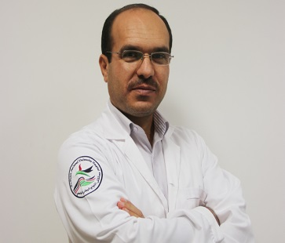
Personal details :

Name : Jihad Mohammad Hamaida
Date of birth : 23/12/1970
Nationality : Palestinian
Address : Palestine , Ramallah
Cell phone number: +972599100655
E-mail : jihad.hamaida@najah.edu

Education :
2006 Palestinian Board in Diagnostic Radiology
Palestinian Medical Council , Ramallah, Palestine
2005 Jordanian Board in Diagnostic Radiology
Jordanian Medical Council , Amman, Jordan
1999 Bachelor of Medicine and General Surgery / M.B.B.S.
Faculty of Medicine , University of Jordan , Amman, Jordan
1992 General Secondary Education Certificate Examination
Al-Nahda Al-Arabiya Secondary School , Tulkarm, Palestine

Personal Experience :
Jun. 2014 – Current Head of Radiology Department and Director of Residency program , An-Najah
National University Hospital , Nablus, Palestine.
Assistant professor of Radiology and Coordinator of High Speciality of
Diagnostic Radiology , Faculty of Medicine and Health Sciences , An-Najah
National University , Nablus, Palestine
Aug. 2011 – Jun. 2014 Head of Radiology Department , Al-Ahli Hospital , Hebron, Palestine
Aug. 2010 – Jul. 2011 Head of Radiology Department , Arabcare Hospital , Ramallah, Palestine
May 2007 – Jul. 2010 Head of Radiology Department , Al-Ahli Hospital , Hebron, Palestine
Oct. 2005 – Apr. 2007 Radiologist , Arabcare Hospital , Ramallah, Palestine
Jul. 2001 – Jul. 2005 Residency program in Diagnostic Radiology, Islamic, Hospital, Amman, Jordan
Nov. 2000 – May 2001 Ward Physician , Jericho Hospital , Jericho, Palestine
Sep. 1999 – Aug. 2000 Intern / House Officer , Islamic Hospital and Zarqa Hospital , Jordan

Professional Memberships :
Oct. 2017 – Current Member of the Scientific Committee of Diagnostic Radiology and Medical
Imaging, Arab Board of Health Specializations .
Apr. 2015 –Current Member of the Scientific Committee of Diagnostic Radiology, Palestinian
Medical Council
Jan. 2006 Member of Palestinian Association of Radiologists .
Sep. 2005 Member of Jordanian Association of Radiologists .
Sep. 1999 Member of the Jordanian Medical Association.

Conferences and Workshops :
- Aug. 2018 Effective Management and Leadership course , Glasgow, UK
- Feb. 2018 GE Radiology Forum , Athens, Greece
- Apr. 2017 Palestinian Medical Council OSCE workshop , Ramallah, Palestine
- Sep. 2015 8th Arab Radiology Conference , Amman, Jordan
10th Jordanian Radiology Society Conference , Amman, Jordan
- Apr. 2013 6th Arab Radiology Conference , Algeria, Algeria
- Nov. 2011 Hip Ultrasound Basic training , Bethlehem, Palestine
- April 2010 3rd Radiology Conference , Amman, Jordan
- Apr. 2007 The First Arab Radiology Conference , Amman, Jordan
- Apr. 2005 6th International Radiology Conference , Amman, Jordan
- May 2002 MEDIS Seminars in Diagnostic Radiology Imaging , Amman, Jordan

Languages :
- Arabic : Spoken and written
- English : Spoken and written

References Will be Furnished Upon Request.

