Dr. Salaheddin Abed Jawad Ali Yassin
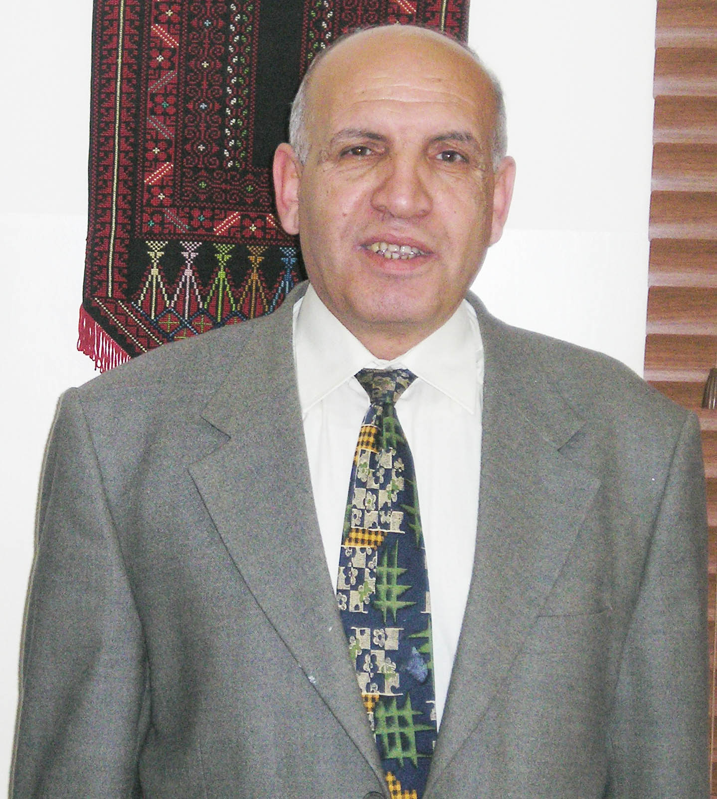
DIRECTOR OF Measurement ad Evaluation Center
Dean of Faculty of Educational Sciences 2007-2008
Director General, Curriculum Development Center 1997 to 2007
Ministry of Education and Higher Education
Lecturer, College of Education, An-Najah National University, Nablus, Palestine
Office Tel: 972-9-2345113
Home Tel: 972-9-2342594
Jawwal: 0599-702-086

Education

1958 - 1968 Al-Berih Al-Jadedeh Secondary Boys School from grade one to grade ten.
1968 - 1970 Al-Hashimia Secobdary School, Al-Berih, Palestine General Secondary Certificate (Tawjehi).
1970 - 1974 University of Jordan, Amman, Jordan B.S. (Mathematics).
1979 - 1981 Middle East Technical University, Ankara, Turkey (M.Sc. Mathematics).
1986 - 1991 Florida State University, Tallahassee, Florida, United States Of America, Ph. D (Mathematics Education).

Professional Experiences
2008 to present DIRECTOR OF Measurement and Evaluation Center
2006-2008 Dean of Faculty of Educational Sciences
2006- 2007 Assistant Prof., Mathematics Education in the Methods of Teaching Department. College of Education, An-Najah National University, Nablus, Palestine
1997 - 2006 General Director of Curriculum at the Ministry of Education.
1990- 1996 Assistant Prof., Mathematics Education in the Methods of Teaching Department. College of Education, An-Najah National University, Nablus, Palestine.
Assistant Prof. Mathematics Education, Jerusalem Open University, Tulkarm, Palestine, (Part time).
Assistant Prof. Mathematics Education in the Department University, Abu-Dies, Jerusalem, Palestine, 1993-1995 (Part time).
1990 - 1991 Lecturer of Mathematics Education in the Department of Curriculum and Instruction, College of Education at Florida State University, Tallahassee, Florida, United state of America.
1987 - 1990 Assistant of Mathematics at the Math help center at Florida State University, Tallahassee, Florida, USA.
1981 - 1986 Lecturer of Mathematics at the mathematics Department, College of Science, An-Najah National University, Nablus, Palestine.
1980 - 1981 Research Assistant in mathematics, Middle East Technical University, Ankara, Turkey.
1974 - 1979 Mathematics Teachers for Secondary school in Ramalla
1974 - 1975 Al- Berih Al-Jadedeh Secondary Boys School.
1975 - 1976 Rammalla Secondary Girls School (Part time)
1976 - 1979 Al-Hashimia Secondary School, Al- Berih, Palestine
1976 - 1979 Mathematics teachers at Teachers' Training Center in Ramalla Palestine (UNRWA)
1976 - 1979 Training mathematics teachers in Modern Mathematics during the summer vacations.
Management Experiences
2008- Present Director of Measurement ad Evaluation Center

2006- 2008 Dean of Educational Sciences
2004- Present Member of The National Accredited Quality Assurance Committee.

1993- 1996 Chairperson of the Department of Methods of Teaching, College of Education, An-Najah National University, Nablus, Palestine.
1993- 1996 Director of the Teachers Training Program (B.S.) representing An-Najah National University at the General Council of Higher Education.
1992 - 1994 Vice President of the National Palestinians Team for Mathematics in the project for reunion the curriculum of Mathematics in both West Bank and Gaza.
1995-2005 Director of The Palestinians Mathematics Olympiad for the Northern region in Palestine (Nablus, Jenen, Tulkarem, Salfet, and Qalqelia).
2006-to present General Coordinator of The National Palestinian Mathematics Olympiad.
To 1994 Elected Member of the College of Education Council at An-Najah National University.
To present Elected Member of the Graduate Studies College Council at A- Najah National University.

Curriculum Development Experience: 1997-2006

- Participated in the Ministerial Curriculum Committee for the preparation of the New Palestinian Curriculum Plan, approved by the Palestinian Cabinet and Palestinian Legislative Council, 1997-1998;
- Supervision of 32 teams that prepared the guidelines to all subjects for 1 through 12 school grades;
- Administration of the development and production of school textbooks for 1st through 12th grades, including authoring, design, illustration, and enrichment;
- Supervising the publication of English language school books for grades 1 through 12, in cooperation with the British MacMillan Publishing Co.;
- Representing the Palestinian Ministry of Education and Higher Education in preparing the Vocational and Technical Education and Training Strategy Plan;
- Participation in producing the Cultural Educational Series for adult education.
- Training Materials experiences:

- Preparing for leadership manuals to The Coalition for Accountability and Integrity “ Transparency Palestine “Amman” for teaching and training in
- Three days workshops Train Head masters, Supervisors, and teachers from all districts 50 persons from each city:- Jerusalem, Rammalla, Bethlehem, Hebron, Jensen, Jericho and Gaza.

Tasks:
- Responsible for the Humanities and Sciences and Vocational Departments: For all school subjects required in the general education.
- Educational supervisor for 450 textbooks, teacher’s manuals, and other schools materials.
- Member of 10 Ministerial approval committees, such as standard for school buildings, the five year plan,
- Instructs on curricula development techniques
- Instruct textbook developers on topics: life skills, human rights, child rights, women rights, sciences and mathematics and technology
- Conducted T.V programs on Education and Curricula
- Took part in formulation reports writing.
- Drafted work- plans
- Wrote evaluation reports
- Member of curricula steering committees
- Lead drafting a guide for textbook developers
- Instruct material developers on instructional design, assessment
- Advise on setting up a technical dept. for textbook layout , illustrations, editing, image banking and in-house style
- coordinate curricula evaluation and teachers training.

Academic Activities

- Helping many students in statistical analysis for master's thesis, and validation of the scientific tools for them.
- Writing a book titled “Methods of teaching mathematics,”
- Participating in and attending many international and local educational conferences representing An-Najah National University.
- Prepared and modified all graduate and undergraduate programs in methods of teaching sciences, Arabic Language, English Language, Social Studies, Islamic Studies, Vocational Training, and mathematics, approved by the University Board at An-Najah National University, and applied in 1995.
- Participated in preparing the master program in Curriculum and Instruction that was established in the College of Education in 1995.
- Preparing unpublished materials in mathematics teaching for graduate and under-graduate courses at An-Najah National University. Programming and analyzing data using Statistical Package for Social Sciences (SPSS).
- Member of the National Council of Teachers of Mathematics (NCTM) from 1986 to present, USA.
- Member of E-Learning at at An-Najah National University
- Coordinator of Standard of School Constructions
- Coordinator of the Strategic Planning at An-Najah National University
- Member of the Accreditation and Quality Assurance Commission (Ministry of Education and Higher Education.
- Authoring Teacher Manual for the First grade for all subjects (Arabic, Religion ed., Math, Science, Social Studies, Civics
Personal Information
Born in Jerusalem on 15 November 1950; married with five children.

Conferences Attended
This is a list of international conferences attended to country, type of conference, hosted by, Address, type of participation, title of the conference and date.
1- USA Conference: National Council of Teachers of Mathematics, Orlando Florida Workshops April 1988

2- USA Conference: National Council of Teachers of Mathematics Salt Lake City April 1990

3- Japan Conference: Study Visit Government of Japan Tokyo NIER 2-2 / 1-3 / 1997

4- Morocco Conference: Arab country Aleskow Al-Reiad Ministry of Education representation Deo. Sec. curr. 20-Dec-1997.

5- Swiss / Geneva Conference: International Bureau of education Geneva Planning, administration and legislation Sep 11th-18th 1998

6- Morocco Conference: Regional UNESCO and UNDP Al-Rebat Ministry of Education representation Human Rights Education in Arab countries Feb 17th-18th 1999.

7- Malta Conference: Regard Malta Ministry of Education representation The establishment of a Mediterranean Network on the management of curriculum change March 2000

8- Italy Conference: Government of Italy Ministry of Education representation Human rights June 2000

9- Belgium Conference: Study Visit Government of Belgium Brussel Study Visit.

10- Franc / Paris Conference: Study Visit Government of Franc Paris Study Visit CIEP 29-11/7-12/2003

11- Jordan / Amman Conference: International World Economic Form Amman Paper presented P.E July 2004

12- Norway/Oslo Conference: International The Oslo Coalition on Freedom of Religion or Belief Oslo Paper presentation Teaching for Tolerance, Respect and recognition in relation with religion or belief Sep 2nd – 5th 2004.

13- Britain /London Conference: Think Tank Meeting British Council London ICT in Education Regional project First Think Tank Mar 6th-11th 2005.

14- Egypt / Cairo Conference: Regional UNESCO Cairo Ministry of Education representation History, Civic, N. ed. Nov 24th-26th 2005.

15- Jordan Conference: Regional German Amman German 22nd - 24th / mar/2006.

