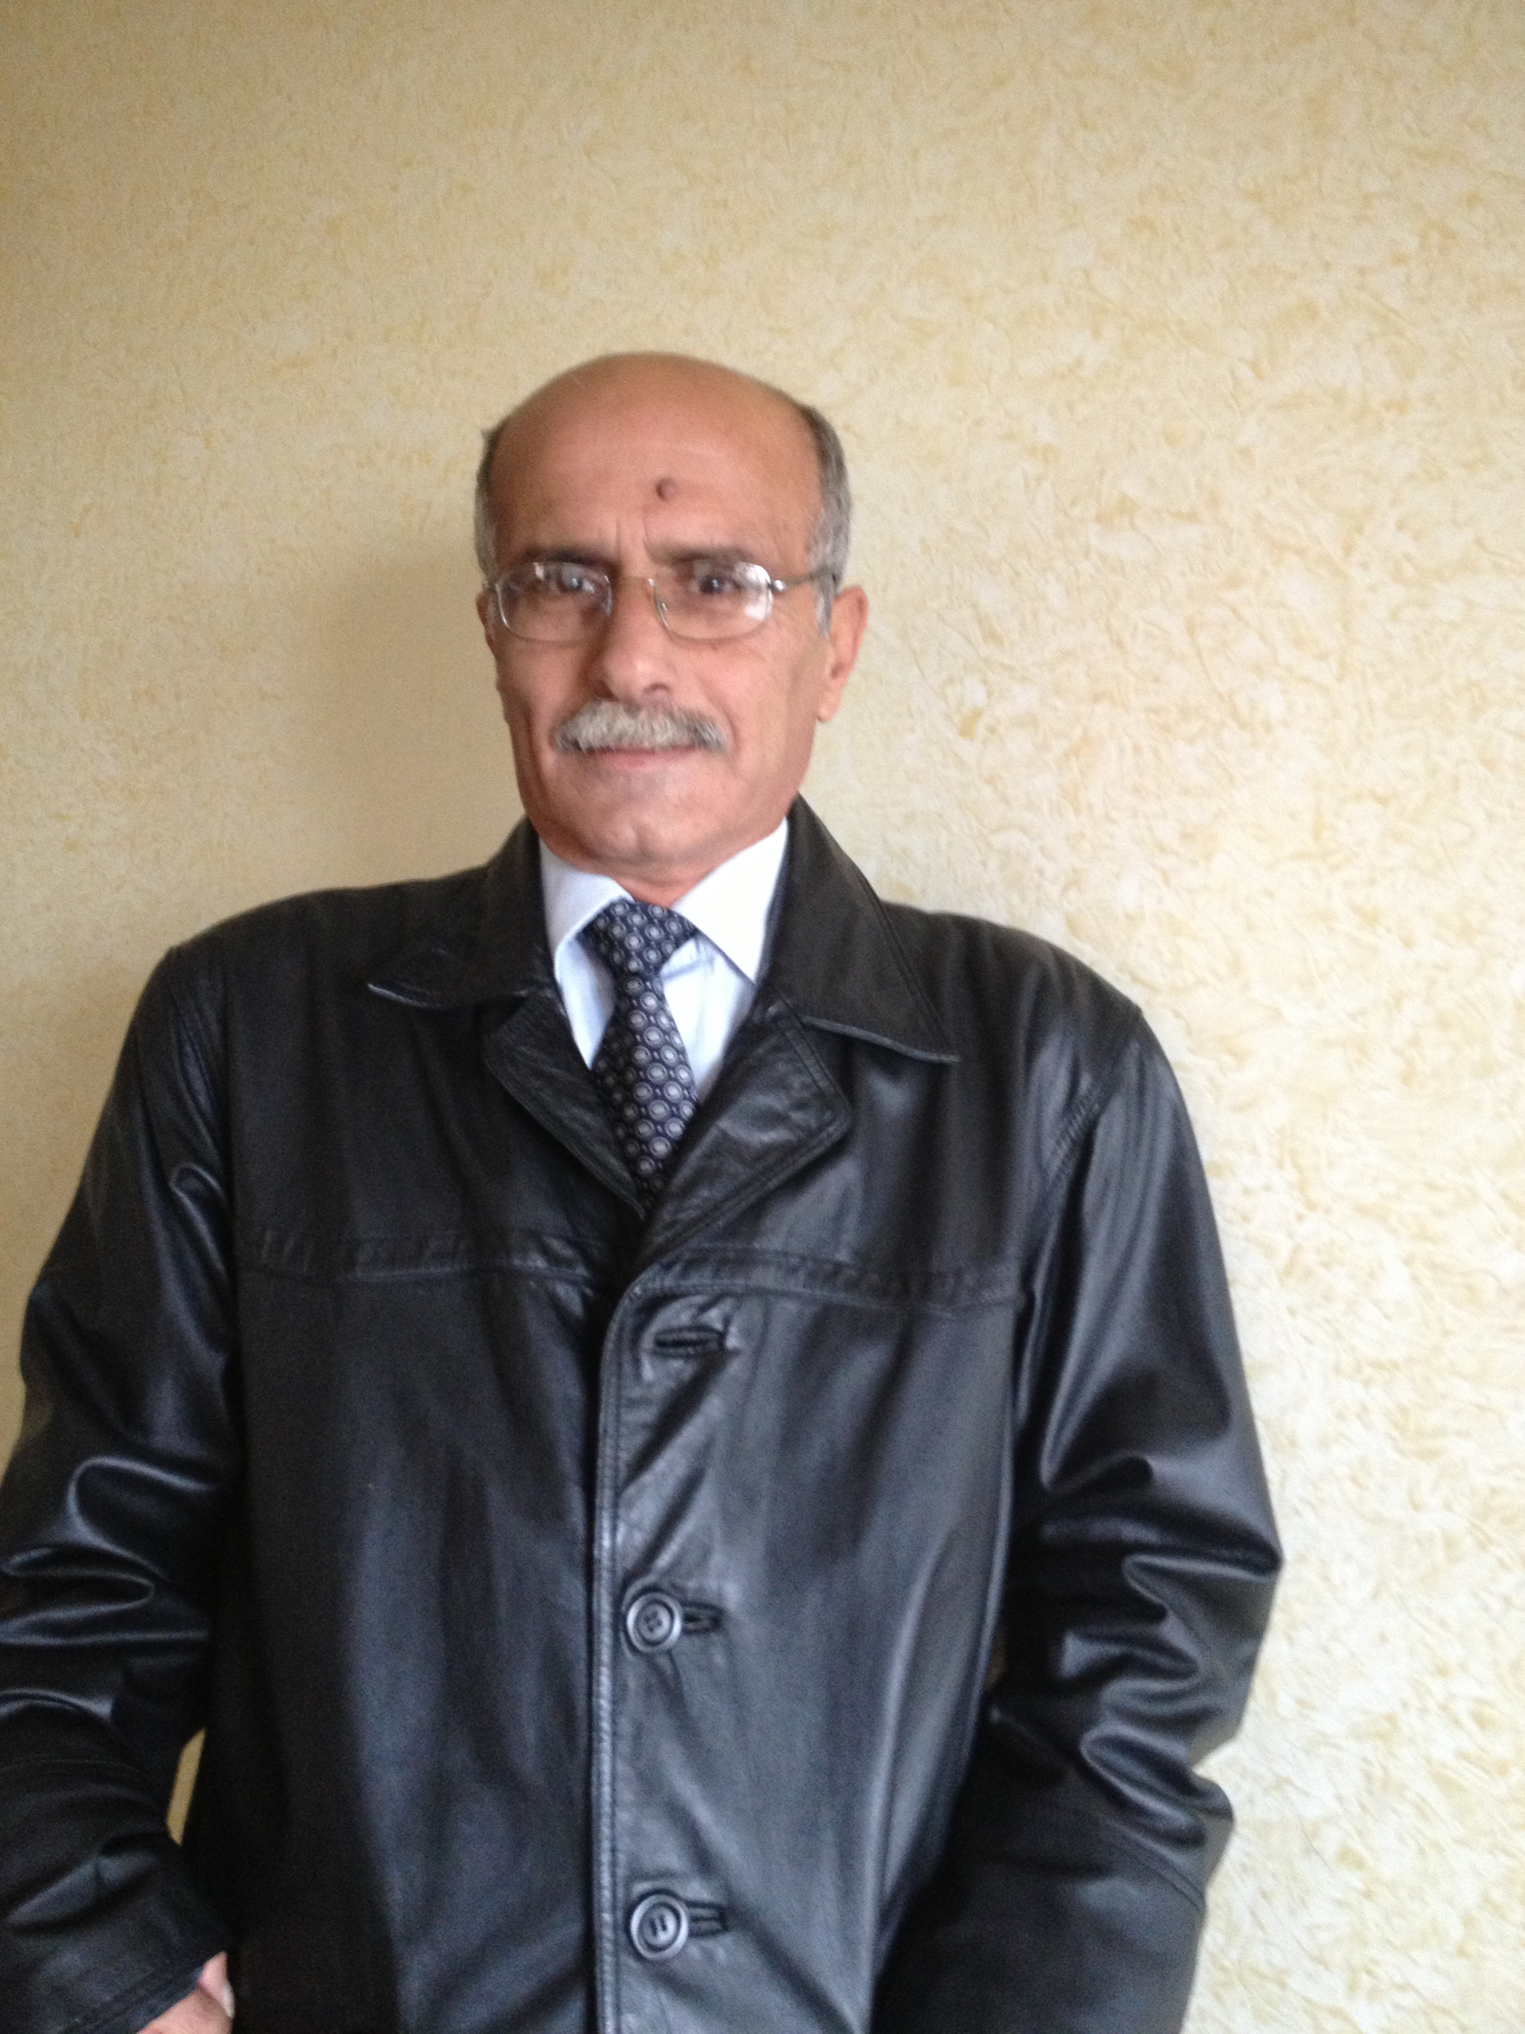

WAHEED J. JONDI (Certificates)

WAHEED J. JUNDI (Passport)

Associate Professor of Organic Chemistry

Department of Chemistry, An-Najah N. University, P.O.BOX 7, Nablus, West Bank, Palestine

E-MAIL: waheedjj@najah.edu waheedjj@yahoo.com

Personal:
Date of Birth: August 8th, 1955
Place of Birth: Yatta, Hebron
Nationality: Palestinian
Material Status: Married
Number of Children: 9

Degrees and Education:

Ph.D. Organic Chemistry (1990), English ; UMIST, Manchester.
Thesis:
“Reactions of Hydroxylamines and Oxime Salts with Polyfluoropyridines and Polyfluoroarenes “

M.Sc. Organic Chemistry (1982), English; The Univ. of Jordan.
Thesis:
“Reactions of Benzofurazan N-oxide with Secondary Amines”

B.Sc. General Chemistry (1979) English; The Univ. of Jordan

Honors and Awards

Research Assistantship | UMIST / U.K. | 1987-1990
ORS Award | Committee of Vice-Chancellors / U.K. | 1987-1990
Teaching Assistantship | UMISIT / U.K. | 1987-1990
Teaching Assistantship | The Univ. of Jordan | 1979-1982
Student Scholarship | Ministry of Education/ Jordan | 1975-1979
PROFESSIONAL EXPERIENCE (TEACHING & RESEARCH):
ARAB AMERICAN UNIVERSITY ,(part time) (2007-2009) Jenin, Palestine.
Teaching:
- Organic Chemistry and organic labs
- Polymer Chemistry

AN-NAJAH NATIONAL UNIVERSITY, Chemistry, PO Box 7, Nablus, West Bank
Instructor (1982-1987)

Assistant Professor, In Organic Chemistry (1990-1996)

Associate Professor, in organic Chemistry (1996-Now)

Teaching:*
1) Advanced Organic Chemistry (senior level Chem. 23431)
2) Advanced Organic Chemistry (M.Sc. Chem. 423531)
3) Special Topics in Organic Chemistry (senior level Chem. 23483)
4) Organic Chemistry I, II & III and laboratories (Chem. 23231, 23232, 23331, 23235 & 23335)
5) Organic Chemistry for biology……and laboratory (23233 and 23237)
6) Organic Chemistry and laboratory for medicine (Chem. 23236) and (7004002)
- Organic Spectroscopy ( Chem. 23433)
- Organic Spectroscopy for M.Sc. (423532)
9) Identification of Organic Compounds (23432)
10) Organic Chemistry for Pharmacy I & II and their laboratories (10211, 10213, 10212, 10213, 102219 and 102220)
11) General Chemistry (Freshman Classes) lecture & laboratory
12) Organic Chemistry for Chemical Engineering (23238)
13) Special Topics in Organic Chemistry for M.Sc., (423583)
14) Organic Technology**

* I have taught some of these courses more than 50 times.
** The department has stopped releasing this course.

Research:
(1) Cluster versus non-cluster catalysis in olefin thermal isomerization and hydrosilylation.
(2) Naturally Occurring Naphthoquinone: its Isolation, Sepectrophotometric Determination.
- The Catalytic Activity of Polysiloxane-supported Metalloprophyrins in Olefin Oxidation Reactions: the effect of the support on catalytic activity and selectivity.
- Preparation of new supported oxidizing and reducing agents that can be applied to hydrocarbons.
- . The nucleophilic substitution reaction of arenes and heteroarenes (i.e. pentafluoropyridine) , which includes the introduction of oxygen ,nitrogen and carbon substituents in difficult position of polyfluoronated aromatic rings, such as the 2-and 3-positions of pentafluoropyridine.
- Isolation, characterization and synthesis of active ingredients exist in certain medicinal plants.
- Modification of biologically active compounds isolated from plants and studying the biological activity of these modified compounds.

UNIVERSITY OF MANCHESTER, PO Box 88, Manchester M61 1QD , England
Teaching Assistant, (1987-1990)
Teaching: Practical Organic & Practical General Chemistry Classes for Sophomore Students. .
Research:
- Reactions of Diethylhydroxylamine, oximes and Hydrazones Salts of Sodium, Lithium and Potassium with Poly Haloaromatic and Heteroaromatic Compounds.
- Nucleophilic Aromatic Substitution on the 2-Position of Pentafouropyridine

The University of Jordan, Department of Chemistry, Amman, Jordan
INSTRUCTOR (1979-1982)

Teaching:
- Practical Organic Chemistry 1 and 2
- Practical Inorganic Chemistry
- Practical General Chemistry 1 and 2
- Identification of Organic Compounds

Research:
Reactions of Benzofurazan N-oxide with Secondary Amines

The Ministry of Education:
Teacher at Secondary School (1979-1981)

THESIS SUPERVISION and CO-SUPERVISION:

- M.Sc.
  - Afaq Kilani
  - Mohammad Suliman
  - Aqab Amer
  - Saeda Dado
  - Hisham Abed (2009)
  - Waseem Mansor (still on)
  - Somoud Yaseen (still on)
  - And many others

- Ph.D.
a) Ahmad Hamaydeh (2010)

ADMINISTRATION:
- Chairman, Chemistry Department. Annajah N. University (2000-2004)
- Chairman, General Safety Committee. Annajah N. University (1998-2005)
- Chairman, General Safety Committee. Annajah N. University (2007-2008)
- Many Other Departmental Committees

PUBLICATIONS:
1. R.E.Banks, Waheed J. Jondi and A.E. Tipping. Reactions of Sodium Diethylnitroxide with Fluorobenzenes, Pentafluoropyridine and Halogenopyridines. J.Flour. Chem., 44 (1989) 441..

2. R.E.Banks, Waheed Jondi and A.E. Tipping. S_{N}Ar Displacement of Fluorine from Pentafluoropyridine by sodium oximate: Unprecedented Substitution Patterns., J.Chem. Soc., Chem. Commun. (1989). 1268

3. H.S. Hilal W. Jondi, S. Khalaf and R.Abu Halaw. Olefin hydrogenation and isomerization catalyzed by Ru₃(CO)₁₂ and its derivatives. Cluster vs. non-cluster catalysis. J. Organometallic chemistry, 452 (1992) 161-165

4. H.S. Hilal, W. Jondi, and S. Khalaf . Cluster Versus non-cluster catalysis in olefin thermal isomerization and hydrosilylation in the presence of Ru₃(CO)₁₂. J . Organometallic Chemistry ; 452 (1993) 167-173.

5. M.A. Al-Nuri, M.A. Hannoun, N. A. Zatar M.A. Abu-Eid, Waheed J. Al-Jondi and Ahmad I. Hussein. Plumbagin, a Naturally Occurring Naphthoquinone: its Isolation, Sepectrophotometric Determination in Roots, Stems and leaves in Plumbago Europea L. Spectroscopy letters, 27(4), 409-416(1994).

6. H.S. Hilal, Waheed J. Jondi and Shukri Khalaf .On the Mechanism of 1-Octene Isomerization and Hydrosilylation reaction Catalyzed by Ru₃(CO)₁₂- An-Najah J. Res., (1994) Vol, II(8), 175-183.”Communication”.

7. R.E. Banks, W. J. Jondi, R. C. Pritchard and A.E. Tipping. (E)-Acetophenone O-(3,4,5,6-tetrafluoro-2-pyridyl) Oxime Acta. Crystal. (1995). C51, 293-295.

8. R.E. Banks, Waheed J. Jondi, R.G. Pritchard and A.E. Tipping. 5-Fluoro-8,8-dimethy e -7-oxo-3,9-diazobicyclo (4,3)nana-5, 9-diene-2,4-dione: a novel Product. Acta. Cryst. (1995). C51, 515-517.

9. W. J. Jondi, R.G. Pritchard and A.E. Tipping. Benzophenone O-(2,3,5,6-Tetrafluoro-4-Pyridyl)Oxime. Acta. Cryst. (1995). C51, 29-293.
10. A.J. Adamson, R. E. Banks, W. J. Jondi., R. G. Pritchard, A. E. Tipping Diethylammonium Tetrafluoro-4-pyridinolate. Acta. Cryst. (1995) C47, 1124-1125.
11. Rajab Abu El-Halawa, M.M. Al-Subu, H.M. Abed and Waheed J. Jondi. Stoichiometry, Kinetics and Mechanism of Oxidation of L-Cysteine by Hexacyanoferrate (III) In Acidic Media. An-Najah J. Res., (1996), 4 (10), 23-41.
12. J. Adamson; Waheed J. Jondi, Anthony Tipping. Reaction of Metal Diethylnitroxide with Pentafluoropyridine, Pentafluorobenzene, Octafluorotoluene and -2-Chloro-3-or5-nitropyridine. J.Fluor. Chem 67 (1996) 67-78;
13. H.S. Hilal, Waheed Jondi, S. Khalaf, A. Kilani, M.Suleiman and A. F. Schreiner.The Catalytic activity of poly (siloxane-supported metalloprophyrins in Olefin oxidation reactions: the effect of the support on catalytic activity and selectivity. J. Mol. Cat. A: Chemical (1996), 113, 35-44
14. M.A. Al-Nuri, Waheed J. Al-Jondi and others. Emodion, a Naturally occurring Anthraquinone: Its Isolation and spectrophotometric Determination in Rumex Cyprious Plants; Spectroscopy Lett. 29(8), 1539-1543 (1996).
15. Waheed J. Jondi. Cluster Catalysis of olefin Hydrosilylation and Isomerzation Thermal Reaction Using Co₄(CO)₁₀(PPh)₂ An-Najah J. Res., (1996) 4(10), 42-70.

16. H.S Hilal, M. Sulaiman, W. Jondi and Shukri Khalf, “Poly (siloxane)-
supported decacarbonyldimanganese (O) catalyst for the olefin
Hydrosilylation reactions: the effect of the support on the catalyst selectivity, activity and stability”, J. Mol. Catal, A: Chemical, 144 (1998) 47-59.
17. H. S. Hilal, M. Sulaiman, W. Jondi, Sh. Khalaf and Moayad Masoud,
Terminal olefin isomerization reactions catalyzed by poly (siloxane)-supported Ru₃(CO)₁₂: the effect of the support on the catalyst selectivity, activity and stability, Al-Azhar University Journal, Gaza, Vol. 1, No.1 (1999), pp.1-21.
18. M.M. Al-Subu, Waheed J. Jondi, S. A. Dado and H.S. Hilal, Kinetics and mechanism of oxidation of 1-octene and heptanal by crown ether-solubilzed potassium permanganate in non-aqueous solvents. Trans. Met. Chem. 27(2002) 223-227.
19. M. M. Al –Subu, M. Hannoun, A. A. Amer, W. J. Jondi and M.J. Musmar.
Oxidation of some alicyclic amines by potassium hexacyanoferrate (III) in alkaline medium: a kinetic and mechanistic study.
An- Najah J. Res. 15 (2001) 29-39.
20. M.M. Al-Subu, W.J.Jondi, A.A.Amer, M. Hunoun, M.J.Musmar.
Osmium (VIII)-catalyzed Oxidation of some cyclic amines by potassium hexacyanoferate (III) in alkaline media. The Chem. of Heterocyclic Cpds 4(2003)559-565.

21. A.I.Husein, M.A.Al-Nuri, N.A.Zatar, W.J.Jondi, M.S.Ali-Shtayeh” Isolation and Antifungal Evaluation of Rumex cyprius Murb Extracts”J.Chem.& Chem.Engin.,2012,6,547-550.
22. A.I.Husein,M.A.Al-Nuri,N.A. Zatar, W. J. Jondi, M.S.Ali-Shtayeh
,I.K.Warad” Isolation and Antifungal Evaluation Juglans regia L Extracts”
J.Chem.& Chem.Engin.,2012( accepted for publication).

23. Ahmad Husein, Waheed Jondi, Mohammed Ali-Shtayeh, Nidal Zatar 2013,Synthesis of Novel Biologically Active Mono Acid Esters Derived from the Constituents of Urtica pilulifera . Iranian Journal of Pharmaceutical Research Manuscript ID: 5287-IJPR

24. Ahmad Ibrahim Husein^{1 ,2*} , Mohammed Saleem Ali-Shtayeh², Waheed Jondi¹, and Nidal Abd-Aljapar Zatar¹ Antioxidant and anticancer activities of six Palestinian plants used in traditional medicine TURKISH JOURNAL OF CHEMISTRY (2013). KIM-1304-71

25. Ahmad Ibrahim Husein^{1,2}, Mohammed Saleem Ali-Shtayeh^{1,*,} Waheed Jebril Jondi², Nidal Abd-Aljapar Zatar² , Ibrahim M. Abu-Reidah¹,and Rana M. Jamous¹. In vitro antioxidant and antitumor activities of six selected plants used in the Traditional Arabic Palestinian herbal medicine. Pharmaceutical Biology 01/2014

FORTHCOMING PUBLICATIONS:

- Preparation and anti-bacterial activity of alkyl 2-, 3- or 4-hydroxybenzoates.
- Preparation and anti-oxidant activity of alkyl 2-, 3- or 4-hydroxybenzoates.
- Preparation and anti-cancer activity of alkyl 2-, 3- or 4-hydroxybenzoates.
- Preparation, characterization and biological activity of hydroxybenzoates.
- Preparation, characterization and biological activity of phthalates.

