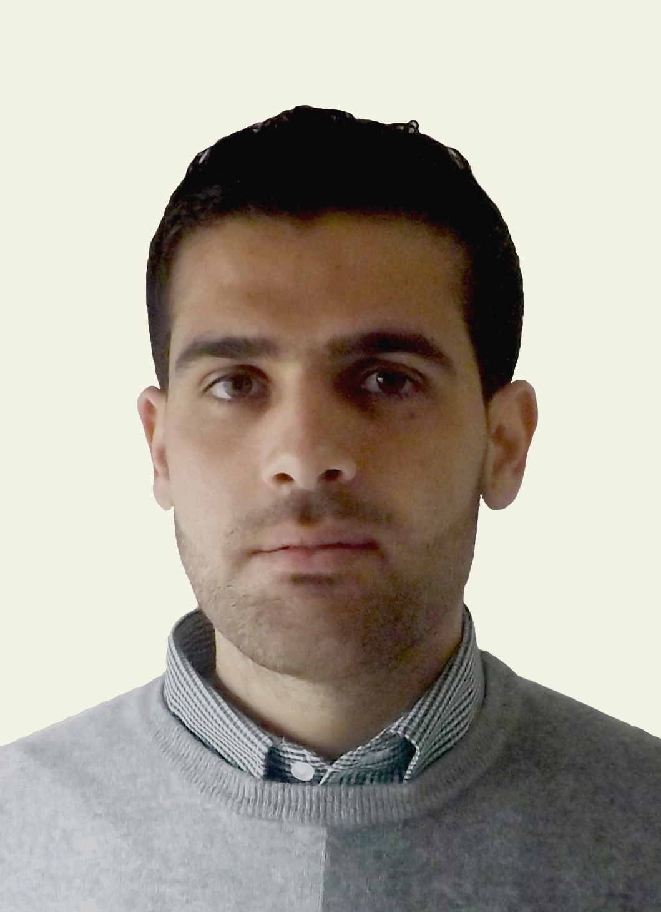

Curriculum Vitae | Phone +972568235186  Telephone +970 – 42411111  E-mail artboy2002@hotmail.com
Ahmed O. M. Abualrob
Objective | To enhance my strategic and creative in solving History of Art problem; moreover studying Art paradigms transition, also my Art skills.
Education  Abstract of  Master Thesis | [2012 - 27 February 2015] UNIVERSITY OF CALABRIA Rende, Italy.  Master degree in History of Art (Specialist).  [2008 - 23 May 2012] AN-NAJAH NATIONAL UNIVERSITY Nablus, Palestine.  Bachelor in Drawing and Painting.  [2005 - 2008] JALBOUN BOYS SCHOOL Jenin , Palestine.  Secondary Education in Human Sciences School.  - The Byzantine- Umayyad Art Transition In Palestine (Medieval Art)  We can't pass the gap between the traditional historical narratives on the Arab conquest of the Near East in the 630s, which influenced the Accepted Archaeological Conventions on one hand, and the ‘art on the ground’. The results of researches with a huge number of data from excavated sites in neighbouring regions, many of which addressed questions on the Artistic, Political, Religious, and Cultural transformation in the Near East during the second half of the first millennium. The Art in Palestine and Jordan during the Byzantine and Early Islamic period is lighted by two sources: Archaeological findings & Eyewitness accounts, the complexity of the transition process from Christian to Islamic rule becomes visible.  Three Byzantine churches were discovered in the village of Beit Jibrin One was decorated with a wonderful mosaic presenting the four seasons, Ancient Church Mosaic With Symbol of Jesus : Have discovered complex mosaics on the floor 1,500 year – old Byzantine church. A large rectangular mosaic ‘ Carpet ’ on the floor of an extravagant palace It’s a tapestry of the land of Palestine and includes fruit trees and animals native to Palestine, The building was modelled on Byzantine architecture and decoration.It’s also includes some Sassanian influence shown in the: jewels, crowns, palmettos and flowers portried in its mosaics. As seen in Umayyad art in general, borrowed motifs were used it in new variations and compositions. Dome of the Rock reflected a number of features that were to become characteristic of later traditions in Islamic art and architecture. This is clear in the mosaics, which are void of human or animal scenes, that’s mean showing at an early period the Muslims’ dislike to presenting images in religious buildings. At the same time, as an architectural monument, the building has complexity of crosscultural, historical interactions that have shaped it. The most striking interior decoration is undoubtedly the stucco sculptures of partially nude women. The carved stucco is exceptional quality in geometric and vegetal patterns Khirbat al-Mafjar; Musicians and dancers painting are repeating subjects in Qusayr ‘Amra , presenting a nude dancers.  The Rise of Byzantine-Umayyad Art Transition in Palestine, The material culture impact on this Transformation from Byzantine to Islamic art in general, It seems that art changes in Palestine and Jordan during that period, the best describ is ‘ intensification and abatement ’.
Work experience | - [March 2015 till now] An-Najah National University – School of Fine Art  MSc Teacher of History of Art .  My job responsibilities include teaching various Painting and Drawing Techniques; Moreover lessons in History of Art for Bachelor students (e.g. Academic Drawing, Painting, Medieval Art, Renaissance Art ..., and Color Theory). I am also helping students in Final projects. Apart from this I am also involved in Research projects with various Faculty members as Research in planning and design & other related function as required.  - [02 March 2016] Participating at exhibition of Art "Resistance" in Bethlehem city.  - [15 January 2016] Participating at international exhibition "ImagoMundi" .  - [24 October 2014] Participating at exhibition of MeditArt "IDENTITY" Aula Magna in Cosenza-Unical.  - [June - July 2012] Volunteer teacher in Ramallah School camp.  - [12-19 November 2011] Participating in (Between Ibal &Jerzim) gallery.  - [13-20 March 2011] Participating in painting of a mural as a commemorating of The Palestinian poet, Mahmoud Darweesh, in Nablus.  - [01-15 February 2011] Participating at gallery in the city of Stavanger, Norway for two  weeks.  - [15 September 2010] participating in the international workshop in Coordination with gallery station in Ramallah with 25 international artists for two weeks.  - [June 2010] Volunteer teacher in Jalboun School camp.  - [June 2006] A month culture exchange program to Toulouse, France.
Computer Skills | - Expert in using MS Excel, MS Word, MS Power Point.  - Working with different kinds of graphics applications such as Photoshop, illustrate.
Personal Data | Name : AHMED O. M. ABUALROB.  Date of Birth : 20 November 1990.  Place of Birth : Saudi Arabia.  Nationality : Palestinian.  Marital Status : Single.  Phone : +972 - 568235186  Telephone : +970 - 42411111  ID : 851643999  Passport No : 2646335 PALESTINE  Email : artboy2002@hotmail.com
Languages | Arabic: Mother tongue.  English: Reading, Writing and Speaking.  Italian : Reading, Writing and Speaking.
Hobbies | Reading Art, History, Philosophy and Literature Books, Painting, Caricature Drawing, Camping, Traveling and Computer.
Rerences | Prof. Gioseppe Roma – Universitiy of Calabria/ Italy.  Director of the Department of Archaeology and History of Arts.  Telephone: +39 0984/494306  Email: G.Roma@unical.it  Waseem O. M. Abualrob – Jenin/ Palestine.  Physics Teacher  Mobile:+97 0569/587387  Email: waseem_abualrob@hotmail.com

