C.V.

- Personal Information 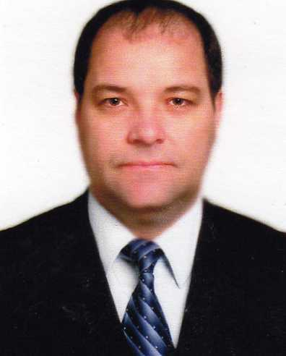

Full Name: Osayd Ali Ahmad Abdul-Fattah________

Permanent Address: Palestine-Nablus Phone: +970 9239322

Present Address: Palestine- Nablus

Phone: __+970 9 239 5322___________ Mobile: +970 599 702 432

Email: Osaydster@gmail.com P.O. Box: ___________________________

Place of Birth : Nablus Date of Birth: 8.12.1965

Marital Status : Married Number of Children: 4

2- Education:-

Name & Location of Institution | Dates Attended From To |  | Degrees or Diplomas obtained
Moscow state institute steel and alloys  Technological University (MISAT.U.) | 1990 | 1993 | Ph.D. in technical sciences 16\12\1993
Moscow state institute steel and alloys  Technological University (MISA T.U.) | 1984 | 1990 | Ms. Metallurgical engineering 9\2\1990

Degrees obtained :
a- Degree: _ Ph.D. in technical sciences
Specialization: Theory of the process of the metals and alloys production.
Title of thesis : _Properties and production of composite material and amorphous metals.

b- Degree :_Ms. Metallurgical engineering Specialization: Theory of the process of the metals and alloys production
Title of thesis : Calculation of technological parameters of Rapid hardening based on research of physical properties of Ni43Mn50Fe7 alloy .

3- Work Experience:-
a: Teaching Experience:
Name & Location of Institution | Employed  From To |  | Rank
An-Najah National University | Jan/2012 | Till now | Assistant Professor MEN department
Moscow state institute steel and alloys  Technological University (MISAT.U.) | 2004 | 2010 | Research project, manager
Birzeit University | 1998 | 2005 | Assistant Professor MEN department
Moscow state institute steel and alloys  Technological University (MISA T.U.) | 1993 | 1998 | Postdoctoral research

b: Other work experience:-

Name & Address of employer | Date  From To |  | Position
NAPCO, Nablus | 1998 | 1999 | Project Manager, melting section &Q.C.

4- Objectives:-

a: Teaching courses;
Thermodynamics(1); Thermodynamics(2); Thermal fluid ; Dynamics; Mechanical drawing(Auto cad); Fluid mechanics; Engineering Measurements Lab; Engineering Metrology and Standards Engineering Measurements; Engineering Materials; Properties and mechanics of materials ; Applied Thermodynamics; heat Transfer; Production and Manufacturing Process(1); Production and Manufacturing Process(2); thermal lab; Design and Production ; Graduation Project (1); Graduation Project(2) ; Metallurgy; Properties of Engineering Materials; Engineering Workshop; Manufacturing Processes ; Special Topics Advance Engineering Materials ; thermal sciences; Heat treatment ; Corrosion engineering; composite materials .

5- Language

- Arabic
- English
- Russian



