دور الخرائط الذهنية في حفظ القران الكريم و فهمه
سورة الذاريات نموذجا
The Role of Mind Maps in Understanding and Memorizing the Qur’anic Verses
Adh-Dhariyat Chapter Model

Rana Qadri (Corresponding author)
Faculty of Humanities, An-Najah National University, Nablus, Palestine
+972598946001 E-mail: ranaqadri@najah.edu
Dr. Muhammad Al-Jitan
Faculty of Shari’a, An-Najah National University, Nablus, Palestine
+970 598 213 341 E-mail: m.jetan@naja.edu
ملخص البحث

من المقاصد القرانية التي اجتمعات عليها نصوص القران و السنة فهم آيات القران و تدبرها و حسن استحضارها على اختلاف الوسائل المساعدة على الفهم و الحفظ في كل زمان و مكان. و في القرن الذي نعيش فيه برزت الخرائد العقلية كوسيلة من وسلئل ادخال النعارف على العقل وفق نظام خرائطي يشبه بتركيبه الخلية العصبية. فإذا ما كانت طريقة الادخال منظمة فيحسن عندئذ استرجاعها عند الحاجة مستحدمين بذلك صورا هي انعكاس للمعرفة و خطوطا متعرجة تحاكي الخطوط العصبية، و ألوانا تتميز بها أصول و فروع تلك المعرفة.
و حسن الاستفادة من هذه الوسيلة المعاصرة في فهم آيات القران الكريم و حفظها مما تدعو إليه العقول السليمة وفق ضوابط تتناسب و القران الكريم. و لأنه من كلام الله عز و جل لا من كلام البشر فإنه من المعارف القرانية ما لا يصلح أن نمثله بصور كالايات التي تتحدث عن ذات الله و صفاته.
و من العلوم الشرعية التي نعتمد عليها في توظيف الخرائط العقلية في القران الكريم: التفسير التحليلي التفسير و الموضوعي و علم المناسبة. فجاءت هذه الدراسة لتوظيف علم الخرائط في فهم آيات سورة الذاريات و حفظها و التي سميت: "الخرائط العقلية و دورها في فهم القران و حفظه: سورة الئاريات نموذجا"
الكلمات المفتاحية: خريطة عقلية، حفظ القرآن، مقاصد السور القرآنية، مناسبات السور، التفسير الموضوعي
Abstract
Braise be to Allah Who perfected the structure of the Qur’an thus made it one unit starting from its first word up to the last; its origin is stable and its branches are fruitful. Peace be upon the Prophet Muhammad, the prophet of mercy, his kinsfolk, followers, and the Qur’an masters.
Amongst the purposes of the Qur’an on which the Qur’anic verses and the prophetic sayings agreed is understanding, memorizing, and well recalling the verses of the Qur’an regardless of assisting tools that help in achieving such goals. In this contemporary century, the mind maps have appeared as a means to help introduce information and knowledge to brains adopting the maplike structure that resembles the neuron structure. As long as the way of introducing information is systematic, it can be easily memorized as well as remembered when required. Such a process makes use of creating images that resembles reality and knowledge as well as using zigzag lines similar to neuro cells.
This contemporary means, the mind map, is well exploited in comprehending, understanding, and memorizing the verses of the Qur’an; however, it should not be adopted freely; rather, it’s restricted by rules specific to the revealed Qur’an; these rules restrict picturing since there are verses that describe Allah and His characteristics, such issues are metaphysical and thus cannot be pictured.
We depend on certain sciences specific to Islam when exploiting mind maps in memorizing the Qur’an such as analytical interpretation, subject-based explanation, occasions of revelation and others. Thus, this study is used to employ such an approach to understand and memorize the verses of Adh-Dhariyat Chapter. This study is called “The Role of Mind map in understanding and memorizing the Qur’anic Verses; Adh-Dhariyat Chapter Model.
Keyword: Mind map, Memorizing the Holy Qur’an, Qur’nic Chapters’ purposes, Occasions of revelation, subject-based interpretation

Research Significance
- The role of mind maps in organizing information entry to brains and recalling it
- Finding innovative methods to understand and memorize the Holy Qur’an aligned with the current age sciences
- Making use of different suitable ways to help us understand the general and specific Qur’anic purposes
Problem Solving
- What’s mind map’s role in understanding and memorizing the Qur’anic verses?
- What are the constraints of employing mind maps when combining different topics of an individual chapter?
- What are the main themes, other topics, and the mind map of adh-Dhariyat Chapter?
Objectives of the Study
- Displaying the mind maps’ role in declaring the Qur’anic chapters’ purposes and in connecting different topics together
- Knowing the main theme of Qur’anic chapters after drawing a mind map for every chapter
- Knowing the constraints of using mind maps in memorizing Qur’anic chapters
Research Methodology
- Inductive approach: by bringing out and displaying the topics of Adh-Dhariyat Chapter depending on subject-based interpretation
- Analytical approach: by examining the minor topics of adh-Dhariyat Chapter up to its main theme; then drawing the mind map to connect different topics together
Literature review
There are multiple studies that employed mind maps in dividing the Qur’anic chapters into different topics to facilitate memorizing them. Some studied all chapters of the Qur’an such as the study of Sheikh Ibrahim al-Duwaish and the study of Safia Abdul Rahman Al-Suhaibani; however, others studied only one chapter.
However, these two studies, in specific, have some drawbacks. They did not signal or show how to employ mind maps in understanding and memorizing the verses f the Holy Qur’an, nor did they clarify the differences between the concepts used in employing mind maps in other fields far from the Holy Qur’an and what should be used when employing them in the field under discussion.
This study comes to bridge the gap that was left. It concerns with employing mind maps in understanding the Holy Qur’an and memorizing it taking into consideration the constrains to do so. This is justified because what is proper in applying to acquire life knowledge may not be similarly applied in the field of Qur’an as there are certain topics mentioned in the Holy Qur’an which cannot be imagined or pictured such as monotheism or Characteristics of Allah.
Study Plan
First Topic
The Mind Map Concept, its Tools, its Uses:
First: Mind Map Concept
Second: Tools of the Mind Map and Its Uses
Second Topic
Rules of Drawing Mind Maps in Relation to Qur’anic Chapters, and the Most Important Constrains Related to Applying Them
First: Rules of Drawing Mind Maps
Second: Constrains Related to Applying Mind Maps to Memorize Qur’anic Chapters
Third topic
The Mind Map of adh-Dhariyat Chapter: Applied Model
First: Dividing Adh-Dhariyat Chapter Adopting Subject-based Model
Second: The Mind Map of adh-Dhariyat in Relation to Memorizing It
Third: The Mind Map of adh-Dhariyat in Relation to Understanding It

Topic One:
Mind Maps Concept, Tools, Advantages
First Demand: Definition of the Word Map in Arabic
1. In the source language, Arabic, “the word map means kharitah. It’s derived from the root kharata. In Arabic, the linguistic meaning of the word kharat is like you remove things slightly and quickly. For instance, if you say kharat the tree leaves, you mean that you remove the leaves quickly” (Ibn Faris, 395 H, 2/169). “Once you start from the top, you instantly reach to the last part.” (Ibn Manthour, 71 H, 7/280)
2. The word map or kharitah idiomatically means “a piece of parchment or something alike on which geographers draw the Earth.” (Mustafa, et al, 1/228)
What is the relation between the two meanings?
The two meanings are connected in an amazing way. Once you start with a point, you can’t stop before completing the task. Once you start removing leaves for instance, you will reach to the last leave quickly. Similarly, once geographers start drawing a part of the Earth, they will continue drawing depending on the start point whether they follow straight or zigzag directing lines.
Second: Definition of the Word Mind in Arabic
1. The Linguistic meaning of the word aql: In the source language the word mind means ‘aql. This word ‘aql is has many meanings. First it’s the gerund of the verb ‘aqala which means to prevent. “It also means being assured about something.” (Ibn Manthour, 711 H, 11/458) “Moreover, it means literacy. It’s said, he is ‘aqel, if he recognized what he hadn’t known before.” ( Ibn Fares, 395 H, 4/69). In Arabic it also means understanding; “if we say somebody has understanding it means he has ‘aql” (Ibn Manthour, 11/458)
The three meanings are connected. In other words, what made a person do good and avoid bad deeds is what’s so called ‘aql as it prevents him/her from doing bad deeds and urges him/her to do good actions. (Yaseen, 2011)
2. There are so many scholars who idiomatically defined the word aql to finally go over a thousand (Az-Zarkashi, 794 H). They finally agreed on defining aql as cognition and recognition. Islamic obligations are composed whose minds are healthy enough to apply such rules and duties. ( Az-Zubaidi, 1992). Another chosen definition is the desire that leads to knowledge. (Al-Muhasabi, 1971)
Third: The Conceptual Meaning of Mind Maps
Tony Buzan defines the concept Mind maps as a powerful graphic technique which provides a universal key to unlock the potential of the brain. It harnesses the full range of cortical skills – word, image, number, logic, rhythm, color and spatial awareness- in a single uniquely powerful manner. In so doing, it gives you the freedom to roam the infinite expanses of your brain. Buzan, T, (1995). How to Mind Map (Jarir Publishing House, Trans; 4th ed.) Jarir Publishing House (1942).
Scientists give these maps different names as Mind maps, cognitive maps, concept tree, or mental chart. (Bodor, 2012)

Second Demand: Tools of Mind Maps, the Advantage of Mental Maps
First: Tools of Mental Maps
Following the works of Tony Buzan and depending on how such mind maps are written, and following the works that are written on this topic, tools are divided into two parts:
The first part consists of overlapping ideas, Bifurcated concepts, multiple facts, all of which the human mind reserves through multiple senses.
For instance, the multiple topics that adh-Dhariyat Chapter talks about are strongly related from the beginning to its end depending on a fixed system. These topics are ensuring the inevitable Day of Judgement, different groups of people on that Day, punishments of past nations, how livelihood is in Allah’s hands.
The second part is the tangible tools one needs to draw the mind map which are: a blank not lined white paper, crayons and pencils, one’s mind, imagination, pictures, and symbols. (Buzan, 2002/2005)

Second: Advantages of Mind Maps:
There are several advantages of mind maps: Buzan, T, (1995). How to Mind Map (Jarir Publishing House, Trans; 4th ed.) Jarir Publishing House (1942).
- They offer a comprehensive view on a certain topic.
- They enable you to plan for your goals and help you determine your direction.
- They effectively help in collecting the largest number of ideas in one place.
- They assist in solving problems as they propose new intellectual methods.
- They allow you to organize facts in a way similar to the brain way of work.
- They enable you to retain information depending on an organized basis.

Topic Two:
The rules and restrictions of drawing and applying mind maps on the Holy Qur’an:
We have to do different things before we draw a mind map to be applied on any Qur’anic chapter. For example, we have to analyze the verses of the chapter; we have to know the occasions of verses. It’s also important to know the rules provided in a chapter, the different readings of certain vocabulary. Then, it’s vital to distribute verses in any one chapter into different topics, relate the introduction of the chapter with the conclusion depending on the science of occasions of revelation. Finally, some restrictions of applying mind maps should be taken into consideration.
The First Demand: Rules and Basis of Drawing Qur’anic Mind Maps:
- The first rule is examining the interpretation of the Qur’anic Chapter adopting the proper methodology of doing so.
“This means that the interpreter should analyze and interpret the verses depending on their order in the one chapter, interpret the words used, and analyze the syntax there.” AT-Tayyar, Musa’ed (27/8/1424 H), Su’al ‘an At-Tafsir At-Tahlil, Multaqa Ahl At-Tafsir. https://vb.tafsir.net/forum
The main goals of analyzing the Qur’anic chapter are:
- Knowing occasions of revelation of one chapter as they assist in getting the exact meanings of verses
- Explaining the strange vocabulary and ambiguous words in specific
- Knowing the different readings of some words in a chapter and relating such different readings to the main goal of a chapter
- Knowing different stories, if there are some, and how they are related to the chapter

- Dividing the one chapter into sections of different topics
The subject-based interpretation of the Holy Qur’an is a science that cares of studying the similar Qur’anic goals as they are mentioned in one chapter or more. (Mustafa, 2005, p 12)
The subject-based interpretation of the Holy Qur’an has many parts. For example, there is a part which is related to studying the topics of a chapter, knowing goals and aims, and defining the main lines that connect diverse topics together; thus, this science will result in creating a subject-based analysis that forms a new view of the chapter to look like a smoothly one-topic unit. (Al-Khaldi, 2012, p 64)
The main goal of adopting the subject-based analysis of one chapter in accordance with the scientific methodology is to well divide the chapter highlighting the beginning and the end of each topic, defining the major theme and the minor topics without integrating whole topics mentioned in the chapter, nor with distracting the major theme. Then, organizing such gathered information comes such as classifying rules, examples, anecdotes or results.

- Connecting Varied Topics of the Same Chapter Together in Agreement with the Occasions of Revelation
The science of occasions of revelation refers to the historical events that associate verses together and chapters together so as to recognize the reasons behind the order of the Qur’anic parts. Abu Al-‘ala’, Adel. (1425 H. Masabeeh Ad-Durar Fi Tanasub Ayat Al-Qur’an w As-Suar. Journal of Islamic University of Al-Madina Al-Munawwara, (129), p 18, 79.1-1658
The main goal of examining the minor topics of the one chapter, depending on occasions of revelation, is to put all such minor topics of the chapter under a main comprehensive one, then to guess the main general topic of that chapter.
- Specifying the Major Theme of a Chapter after Determining the Topics Which the Chapter Deals With
By completing the prior three demands, the fourth demand has to be completed. It basically depends on specifying the major theme of the chapter where all minor subjects meet. It could by a cognitive issue, intellectual issue, doctrinal issue, historical issue, or one of the Allah’s ways of treating and dealing with His creatures.
The Second Demand: Constraints Related to Draw Mind Maps and Apply Them on the Qur’anic Chapters:
- Concerning Mind Maps Tools:
We should not forget to say that we can freely use mental mind maps’ tools, such as blank sheets of papers, crayons, or zigzag lines; however, we should admit that we cannot draw pictures or connotative images as most chapters’ topics talk about the monotheism which can’t be expressed by images.
- Concerning the Subject-Based Division of a Chapter
Here we have to consider two issues:
How to recognize the minor topic of a chapter:
We can achieve this goal by making use the connotations of words that guide us to recognize each topic. In other words, we can use the initial words of verses to guess the topics; nevertheless, this mechanism should be aligned with the chapter’s goals.
How to recognize the major theme of the chapter:
In general, the major theme of a chapter focuses on faithful, legal, or intellectual issues, or it could be about monotheism of Allah, eternity, or Allah’s way of treating His creatures. The major theme may not be an example, a story mentioned in the chapter. Moreover, the rhetoric oath of Allah could not be a major theme nor could the name of a chapter. A name of a chapter could be relevant to a minor topic of a chapter.

Topic Three:
The Qur’anic Mind Map Applied on Adh-Dhariyat Chapter
Having discussed the theoretical part of the topic, that is, map mind, here we come to the practical part which is applying the mind map on Adh-Dhariyat Chapter. Here we are going to introduce the subject-based division of the chapter which will appear in a following table; then we are going to draw the mind maps related to memorizing and understanding the above-mentioned chapter; such a process will show how fruitful the use of mind maps is.
The first Demand: The Subject-Based Division of Adh-Dhariyat Chapter
The following table shows the subject-based division of Adh-Dhariyat Chapter as we see in figure 1.
First: The major theme of this chapter is the Day of Judgment is inevitable. The verse says:
وَإِنَّ الدِّينَ لَوَاقِعٌ” And verily Judgement and Justice must indeed come to pass”
Figure 1
No. | Verses | Topics | Notes
1 | (1 – 6) | An oath: the Day of Judgement is inevitable  "و الذاريات"  By the (Winds)that scatter broadcast
2 | (7 – 14) | A given example on those who denied the Day of Judgement, Meccan People
3 | (15 – 19) | An example on those who believed in the Day of Judgment (believers)
4 | (20 – 23) | Signs of Allah’s ability, and He owns livelihood
5 | (24 – 36) | The story of Prophet Ibrahim as an example of prophets who were rewarded: his guest, the good news his wife received and the prediction of Ibrahim’s people’s damnation
6 | (37 – 46) | The damnation of unjust people is a sign of the inevitable Day of Judgement  Pharaoh, People of Ad, People of Thamud, People of Noah | complete
7 | (47 – 51) | In front of the Divine Power, you should surrender to Him and leave polytheism
8 | (52 – 58) | This discourse is directed to Prophet Muhammad telling him that it’s people’s tradition not to believe prophets, and not to be afraid of poverty as Allah controls livelihood
9 | (59 – 60) | Torture in the afterlife is inevitable, on nonbelievers: Meccans and the older generations alike

Second: The Explanation of the previous table:
The beginning of Adh-Dhariyat Chapter and its end are related. What’s in between are verses that tell anecdotes about prior nations who believed and who did not; thus, the promise of judgement is inevitable.
In the beginning there are such verses which tell about the day of Judgment and in the end, there is a similar verse that talks about the same promise.
The initial verses are: (Indeed, what you are promised is true.5 And indeed, the recompense is to occur.6)
The last verse is:
(And the woe to those who have disbelieved from their Day which they are promised. 60)
Third: The major theme of the Chapter
Examining the different topics that the Chapter talked about, we can tell that the major theme is in the sixth verse: (And indeed, the recompense is to occur. 6). It is the promise that Allah gave to mankind. Then the chapter mentioned two different types of people: the falsifiers and the true believers. Then the chapter talked about Allah’s ability and how livelihood is in Allah’s Hands. To strengthen the idea, Allah gave an example of His ability which is the story of Ibrahim and his wife and how they were rewarded in present life. Then, the chapter moved smoothly to talk about how the disbelievers were punished in their present life. However, the chapter gave a hint to those who want to escape Allah’s punishment by asking them to believe in monotheism (the oneness of Allah) and to follow His messenger. The chapter also urges the Prophet Muhammad (PBUH) to go ahead in calling people to worship Allah only paying no attention to Quraysh tribe’s stubbornness as the disbelievers’ fate would be similar to previous nations who did not believe in Allah nor did they follow His messengers.
The Second Demand: The Mind Map of Adh-Dhariyat Chapter in Relation to Memorizing It:

First: The Mind Map of the Chapter
The mind map of Adh-Dhatiyat Chapter appears in figure 2.
Figure 2
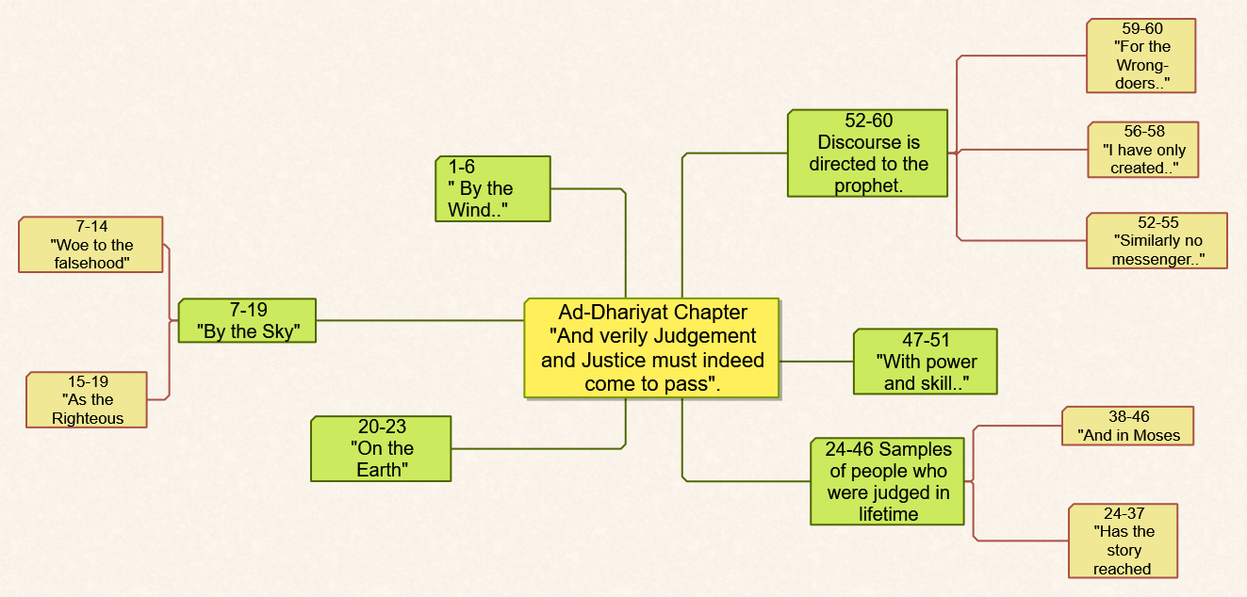

Second: Dividing the chapter into six parts
Adh-Dhariyat Chapter could be divided into six parts. Anyone who would like to memorize the chapter firstly should keep number six in their minds. Then, s/he starts to memorizes each part individually. Such a method, helps in organizing the entry of information in brain cells which in return facilitates memorizing the chapter. This way relates information to the images that are connected to each topic.
The Third Demand: Adh-Dhariyat Chapter Mind Map in Relation to Interpretation:
The following map (see figure 3) shows the Mind Map of the chapter related to interpretation.
First: The Mind Map of the Chapter

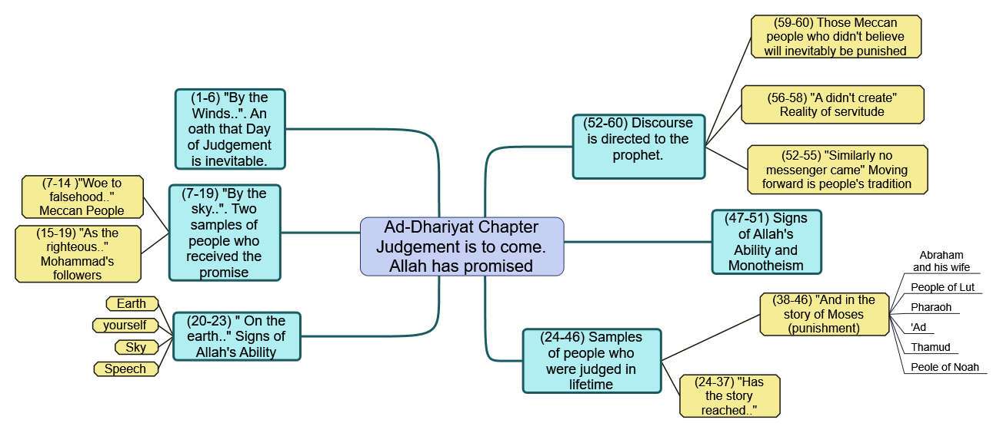
Figure 3

Second: Subject-Based Interpretation:

Having determined the major theme of the chapter which is the promise that Allah gave which assure the recompense in the present life and in the afterlife whether to punish or reward the disbelievers and believers respectively, this promise was introduced by the oath Allah gave to show how important the subject is.
Then the chapter talks about two groups of people who were in the age of the Prophet Muhammad (PBUH). There were the disbelievers who didn’t trust him, nor did they believe in what he said. In contrast, there was the other group of true believers who accepted, trusted and believed in what he said and told them. The chapter also talks about the good rewards that the second group will receive in the Afterlife.
Another minor topic that the chapter mentioned is the story of Prophet Ibrahim and how Allah honored him in the present life. However, the chapter mentioned the punishment and fate that the disbelievers received and met especially those who denied the Day of Judgement.
The chapter mentions the rope by which one can rescue him/herself which is believing in monotheism.
The final speech was directed to Prophet Muhammad (PBUH) to console and comfort him by giving him the example of past prophets with their nations. So, Allah wants hos prophet not to lose patience or be afraid as the universe is standing on a main pillar: worshipping Allah.
The last verse emphasizes what is mentioned in the beginning. The disbelievers amongst people of Quraysh would receive punishment as well as past nations did.

Conclusion and Recommendation
First: The Main Results of the Paper:
- Mind maps are considered to be one of the most important current tools that can well-manage the relationship between understanding and memorizing the verses and chapters of the Qur’an and the brain cells.
- This study is the first study that roots the idea of employing mind maps in understanding and memorizing the Holy Qur’an in agreement with constraints and restrictions that should be applied when being used with such a Holy Book.
- To well make use of mind maps, one should not forget to apply the scientific basis and restrictions of doing so.
Some scientific basis is:
- the employment of analytical interpretation
- the employment of the subject-based interpretation of the one chapter
- the employment of occasions of revelations
- the employment of the science of general and specific goals of the Holy Qur’an
One vital restriction is related to using mind maps’ tools. They should be wisely used as the Qur’an is a revelation not like any other book.
- Adh-Dhariyat Chapter is divided into six minor topics and its major theme is the recompense is to occur.
Second: Most Important Recommendations:
- We hereby invite all schools where students study and memorize the Holy Qur’an to employ mind maps to get excellent students who perfectly memorize the Qur’an.
- We also ask anyone who wrote in this field, using mind maps to memorize the Holy Qur’an to reconsider the constrains and restrictions that this paper has suggested.
References:
Abu-Al’al’, Nader Ibn Muhammad. (1425 H). Masabeeh Ad-Durar Fi Tanasub Al-Ayat Wa Assuwar. Journal Of Islamic University of Al-Madina Al-Munawwarah, (129), 18.
Al-Ghazali, Abu Hamid Ibn Muhammad. (1993). Al-Mustasfa Fi ‘ilm Al-Usool (1st ed.). Dar Al-Kutub Al’ilmiyyah.
Al-Khaldi, Salah Eddin. (2002). At-Tafseer AlMawdu’I Bayna An-Nathariyyah Wa At-Tatbiq (3rd. ed.). Dar An-Nafa’is Lin-Nashr Wa At-Tawzi’.
Al-Muhasabi, AlHarith (1971). Al-Aql Wa Fahm Al-Qur’an (1st ed.). Dar Al-Fikr Lin-Nashr Wat-Tiba’a Wat-Tawzee’.
Al-Qazweeni, Ahmad Ibn Fares Ibn Zakariyya’. (1979). Mu’jam Maqayyes Al-Lugha (1sr ed.). Dar Al-Fikr Lin-Nashr Wat-Tiba’a Wat-Tawzee’.
Az-Zarkashi, Mummad Ibn Bahader Ibn Abdullah (2000). Al-Bahr Al-Muheet Fi Osool Al-Fiqh. Dar Al-Kutub.
Az-Zunaidi, Abdul-Rahman Ibn Zaid. (1992). Masader AlMa’rifah Fi Al-Fikr Addini Walfalsafi (1st ed.). Al-Mu’ayyad Bookstore.
Buza, T. (2002) How to Mind Map (Jarir Bookstore, Trans; 7th ed.). Jarir Bookstore. 2007
Musallam, Mustafa. (1426 H). Mabahith Fi T-Tafseer Al-Mawdu’I (4th ed.). Dar Al-Qalam.
Mustafa, Ibrahim, Az-Zyyat, Ahmad Hasan, Abdul_Qader, Hamed, & An-Najjar, Muhammad Ali.(1989). Al-Mu’jam Al-Waseet (3rd ed.). Dar Ad-Da’wa
Ibn Manthour, Muhammad Ibn Mukarram. (n.d). Lisan Al-Arab (3rd ed.). Dar Sader.
Yaseen, Muhammad Na’eem. (2011). Mabaheth Fi Al-‘aql (1st ed.). Dar An-Nafa’es.
Budoor, Su’ood Al-Abd Al-Muhsen. (1436 H). Al-Khara’et Ath-Thihniyya: Hakeeba Tadreebiyya Fil Khara’et. https://fac.ksu.edu.sa/sites/default/files/lhqyb_ltdryby_mind_mapping.pdf

