Addressing Women’s Issues in Planning for Sustainable Development: A Comparative Study between Kurdish Women in Kurdistan Region of Iraq and Palestinian Women in the West Bank in Palestine

Dr. Emad Dawwas
Urban Planning and City Technologies Department
An-Najah National University, Nablus, Palestine
Email: dawwas@najah.edu
Mobile: +972-595731170

Abstract
The fifth goal of Sustainable Development Goals (SDGs) states that all discrimination against women and girls should be stopped as an essential requirement for sustainable future. Within the context of Kurdistan Region of Iraq (KRI) and the West Bank in Palestine (WBP), it might be early and difficult to talk about gender equality and put it in practice. However, women issues should be clearly stated in the plans and policy documents as one requirement to reach the fifth SDG. This study aims to analyze the extent to which women issues are considered in urban planning process - as one of the most effective tools of sustainable development- in two regions: Kurdish Region in Iraq (KRI) and the West Bank in Palestine (WBP). Referring to a number of urban planning documents from both regions, the analysis was conducted by contextual text analysis for all available planning documents with reference to the 17 SDGs. When comparing the results from KRI and WBP, it is obvious that there is high similarity in the level of interest in women's issues in both regions regarding equality and economic sustainability goals. On the other hand, the results show significant differences in the issues regarding the goals of basic services and the goals of sustainable built and natural environments.

- Introduction
Sustainability as an essential concept for development has been the main reference in planning for future since the publication of Brundtland Commission Report in 1987 (Zahedi, 2008). The same concept was highlighted in the following global conferences in Rio 1992 and Johannesburg 2002 (Linnér and Selin, 2013). The dramatic changes took place in the United Nations Conference on Sustainable Development, held in Rio de Janeiro, Brazil, 2012, when 17 Sustainable Development Goals (SDGs) were announced as bases for sustainable development (Allen et. al., 2018). Among these SDGs there is one specific goal that explicitly addresses the gender equality as a condition for sustainable development, namely SDG5: Gender Equality.
Since then, women are being introduced as one of the most important parties contributing to achieving sustainable development. Therefore, women's role is no less than men's in finding solutions to sustainable development challenges and supporting efforts for a sustainable future (UN Women, 2022). The role of women can no longer be underestimated in many countries of the world, whether developed countries or developing ones. Therefore, addressing problems and other challenges of the sustainable development, requires the involvement of women as a key player on the one hand, and it needs the concerted efforts of all concerned parties, including governments, the private sector, civil society, international organizations and citizens on the other hand (Hirsu et. al., 2020).
Given the differences in economic, social and political contexts across the world, there are varying levels of women's involvement in the sustainable development planning process, and in achieving sustainable development goals (Cicchiello et. al., 2020). This disparity is reflected on addressing women’s issues in planning for sustainable future within different contexts.
These differences increase in regions of wars or that have suffered from wars, especially during the post-war period (Emma et. al., 2018). Wars are usually followed by the process of establishing the state, building institutions, and planning for the future of these regions. It is self-evident that sustainability is the basis for building a post-war state, and that this includes the involvement of women in planning, and that women’s issues are an essential part of planning issues.
The focus of this research is on two areas that have high geopolitical similarity namely: Kurdistan Region of Iraq (KRI) and the West Bank in Palestine (WBP). Both regions went through a series of wars followed by a peace building period. Women in both regions are part of the community and have played an essential role in war and post-war periods.
In KRI, Kurdish women played a main role as a freedom fighter during the several wars that took place in KRI (Saeed Bagheri, 2022). The Kurdish woman in the KRI region was a partner with the man in the process of liberation and defense of the land, which is considered one of the highest levels of partnership between men and women. However, this partnership was quickly broken down and diminished during the peace process, as the role of women drastically receded (Saeed Bagheri, 2022).
This situation is similar to the role of the Palestinian woman who fought side by side with the man throughout the stages of the Palestinian revolution and successive uprisings against the Israeli occupation. Although the Palestinian people are still under the Israeli military occupation and the peace making process has not been completed, Palestinians have gone through the stage of state building. The Palestinians have built all state institutions that form the backbone of the state, a stage similar to the stage of peace in the KRI.
This paper explores what happened during the post-war period and the establishment of the state institutions regarding the women issues in KRI and WBP. The research explores mainly the extent to which the development plans dealt with women's issues referring to the 17 SDGs with special emphasis on the SDG 5: Gender Equality.
2. Methodology and Data Collection
2.1 Study Area
To achieve the goals of the study and to answer the research question, two regions were selected as a spatial extent of the research: The Kurdistan Region of Iraq (KRI) and the West Bank in Palestine (WBP). Both regions are shown in Figure (1) and Figure (2) respectively.
KRI is an autonomous region and located in the north east of Iraq. The KRI is populated by 6.5 million people living in four main regions Dohuk in the north, Erbil in the middle and Sulaymaniyah and Halbja in the south with total area of 46,861.41 sq. Km. (KRSO, 2023)

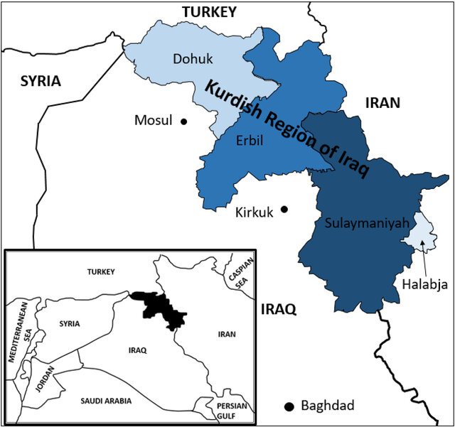
Figure (1): Kurdistan Region of Iraq
Source: Mohammed et. al., 2019

As to the West Bank, it is one of three geopolitical entities in historical Palestine: The West Bank, Gaza Strip and the Occupied Palestine in 1948 as shown in figure (2) below. WBP is located in the middle of the historical Palestine. The WBP is populated with 3.25 million people and has an area of 5,660 sq. Km (PCBS, 2023).
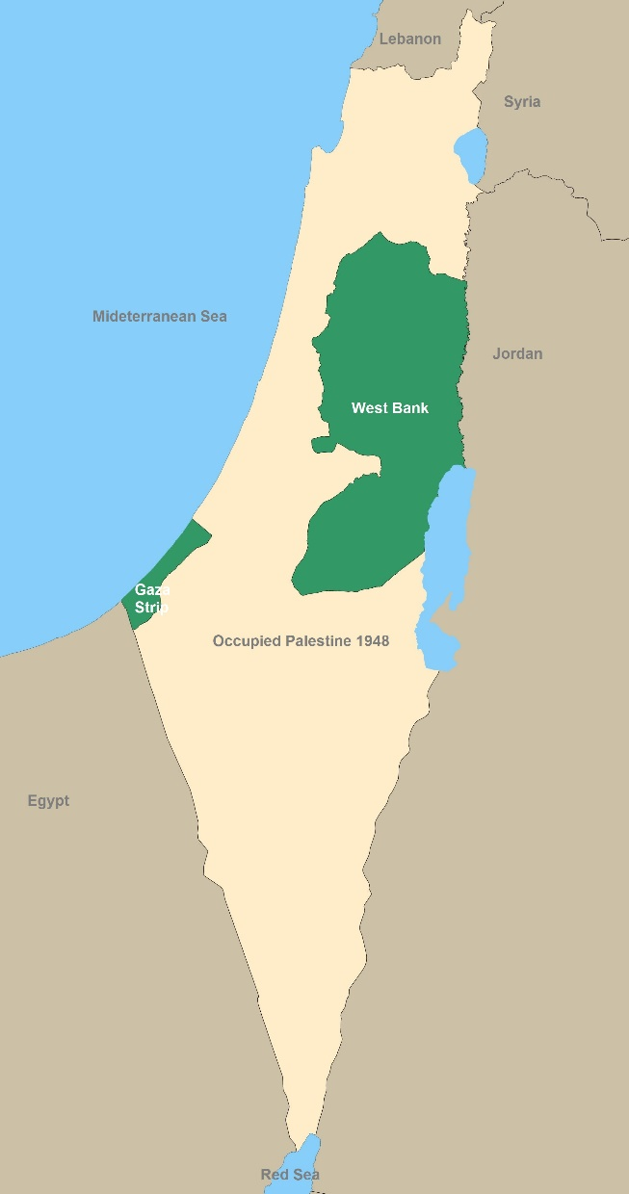
Figure (2): Map of the West Bank in Palestine
Source: Palestine Maps, 2023

2.2 Methodology
As the main focus of this research is to explore the women’s issues as stated in the planning documents, the research methodology is designed to satisfy this specific goal. The methodology is illustrated in figure (3) below.

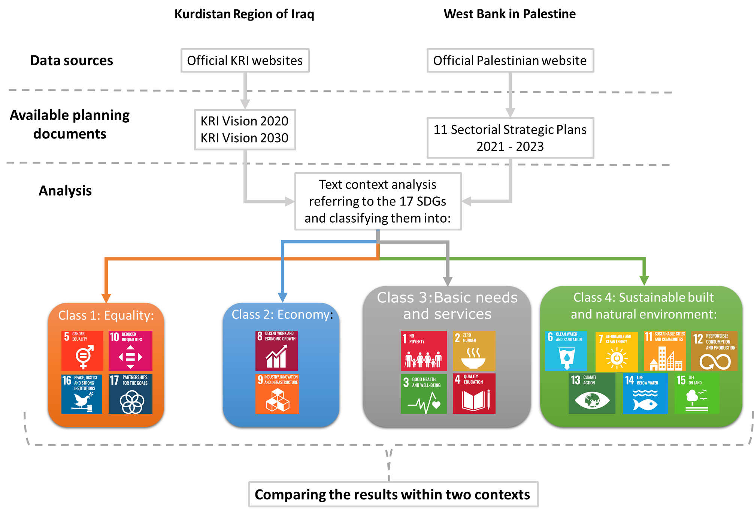
Figure (3): Research Methodology Diagram

The first step is to collect all planning documents available on the official websites in KRI and WBP. This step was a challenging one for the author due to the lack of planning documents, especially in KRI. This is one of the study limitations because the only available planning documents are KRI Vision 2020 and KRI Vision 2030. Both visions provide strategic guidance and technical support for the development of KRI 2017 – 2020 and 2020 – 2030, respectively.
In the Palestinian context, there were abundance of the relevant documents. To narrow down the number of documents in the WBP, the most recent strategic sectorial series of plans were selected including 11 plans prepared by several Palestinian ministries in collaboration with a network of stakeholders in 2021 – 2023.
All available planning documents were reviewed and contextual text analysis was conducted. All paragraphs where the women issues were mentioned were analyzed. The reference in analyzing the text’s context is a list including the 17 SDGs. At the same time, the 17 SDGs were classified into four classes – listed in table 1 below—in order to ease the analysis process and make the result easier to the understand.
The number of mentions for each SDG is written down and summed at the end of the analysis. In the next step, the number of mentions will be attributed to the four classes of SDGs: Class 1: Equity; Class 2: Economy; Class 3: Basic needs and services; Class 4: Sustainable built and natural environment.
Finally, the discussion and the conclusion of the study will be based on the results for the individual SDGs and the aforementioned SDGs classes.

Table (1): Classification of SDGs according to four classes
SDG Class | SDGs
Class 1:  Equality | 5. Enforce Gender Equality: Achieve gender equality and empower all women and girls
 | 10. Reduce Inequality: Reduce inequality within and among countries
 | 16. Guarantee Peace, Justice, and Strong Institutions
 | 17. Build Partnerships for the Goals and strengthen the means of implementation and revitalize the Global Partnership for Sustainable Development
Class 2:  Economy | 8. Create Decent Work and Economic Growth: Promote sustained, inclusive and sustainable economic growth, full and productive employment and decent work for all
 | 9. Increase Industry, Innovation, and Infrastructure: Build resilient infrastructure, promote inclusive and sustainable industrialization and foster innovation
Class 3:  Basic needs and services | 1. Eliminate Poverty: End poverty in all its forms everywhere
 | 2. Erase Hunger: End hunger, achieve food security and improved nutrition and promote sustainable agriculture
 | 3. Establish Good Health and Well-Being: Ensure healthy lives and promote well-being for all at all ages
 | 4. Provide Quality Education: Ensure inclusive and equitable quality education and promote lifelong learning opportunities for all
Class 4:  Sustainable built and natural environments | 6. Improve Clean Water and Sanitation: Ensure availability and sustainable management of water and sanitation for all
 | 7. Grow Affordable and Clean Energy: Ensure access to affordable, reliable, sustainable and modern energy for all
 | 11. Mobilize Sustainable Cities and Communities: Make cities and human settlements inclusive, safe, resilient and sustainable
 | 12. Ensure sustainable consumption and production patterns
 | 13. Take urgent action to combat climate change and its impacts
 | 14. Conserve and sustainably use the marine resources for sustainable development
 | 15. Advance Life On Land: Protect, restore and promote sustainable use of terrestrial ecosystems, sustainably manage forests, combat desertification, and halt and reverse land degradation.

3. Results and Discussion
Referring to the available planning documents for the KRI at the regional level, detailed contextual analysis was conducted and the results will be discussed in the following paragraphs.
The text of the documents was carefully scanned searching for women issues. Each issue’ context was analyzed and attributed to one or more of the SDGs. Eleven SDGs were captured and listed in table (2) below.
Table (2): Results of the text contextual analysis for KRI
SDG No. | Goal | Mentions
 |  | KRI | WBP
SDG 1 | Eliminate Poverty | 2
SDG 3 | Establish Good Health and Well-Being | 1
SDG 4 | Provide Quality Education | 5
SDG 5 | Enforce Gender Equality | 18
SDG 8 | Create Decent Work and Economic Growth | 16
SDG 9 | Increase Industry, Innovation, and Infrastructure | 3
SDG 10 | Reduce Inequality | 7
SDG 11 | Mobilize Sustainable Cities and Communities | 1
SDG 15 | Advance Life On Land | 1
SDG 16 | Guarantee Peace, Justice, and Strong Institutions | 9
SDG 17 | Build Partnerships for the Goals | 4
Total number of mentions |  | 67

Six SDGs were missing from the list of the captured goals in the KRI documents. These missing goals SDG 2, SDG 6, SDG 7, SDG 12, SDG 13 and SDG 14. Among the rest of the SDGs, the fifth SDG was the most repeated in the planning documents with 18 frequencies indicating the importance of the equality in the plan. The second more frequent goal is the eighth SDG with 16 repetitions which also indicates the importance of the economic situation of the women in the KRI. The least is the Health goal (2nd SDG), Mobilize Sustainable Cities and Communities (11th SDG) and Advance Life On Land (15th SDG) with one repetition only.
As to the results from WBP listed in Table (3) below, the statistics show, as expected, more incidents when women issues are mentioned because of the larger number of planning documents and pages in the case of WBP.
Five SDGs are missing from the planning documents of the WBP: SDG 6, SDG 7, SDG 12, SDG 13 and SDG 14. Similar to the KRI, the Gender equality obtained the most attention as it is repeated 34 times, as well as the eight SDG (the economic growth goal) is in the second place.

Table (3): Results of the text contextual analysis for WBP
SDG No. | Goal | Mentions
SDG 1 | Eliminate Poverty | 1
SDG2 | Erase Hunger | 3
SDG 3 | Establish Good Health and Well-Being | 2
SDG 4 | Provide Quality Education | 2
SDG 5 | Enforce Gender Equality | 34
SDG 7 | Grow Affordable and Clean Energy | 1
SDG 8 | Create Decent Work and Economic Growth | 26
SDG 9 | Increase Industry, Innovation, and Infrastructure | 4
SDG 10 | Reduce Inequality | 5
SDG 11 | Mobilize Sustainable Cities and Communities | 1
SDG 15 | Advance Life On Land | 4
SDG 16 | Guarantee Peace, Justice, and Strong Institutions | 14
SDG 17 | Build Partnerships for the Goals | 2
Total number of mentions |  | 98

However, the WBP planning documents, unlike KRI documents, include the second SDG goal (Erase hunger). The documents, in this regard, focused specifically on empowering women in the agriculture sector by giving her agriculture loans, training and enabling her to invest in private agricultural projects. Another difference between the two contexts, is the appearance of SDG7 (Grow affordable and clean energy) in the WBP documents. The Palestinian Economic Strategic Plan states that women should obtain grant to be involved in producing renewable energy.
As to the SDG classes proposed in the methodology section, it is obvious from figure (3) below that results are very similar with minor differences that will be discussed in more details below.
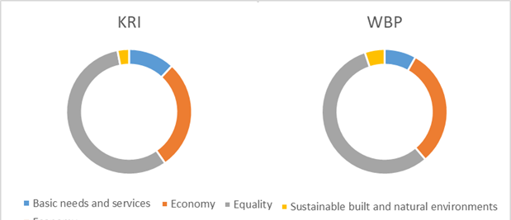
Figure (3): SDGs classes comparison between KRI and WBP
In more details, the results show that the class that obtained the vast majority of planners is the equality class. The equality class in both contexts—the KRI and the WBP— obtained more than 50% of the mentions. In the KRI equality obtained 57% of all mentions, which indicates that equity is a high priority for the planners and the decision maker according to the planning documents. Not far away from these results, in the WBP documents, the equality class obtained 55% of the mentions, which has the same indication about equity being a priority for the Palestinian planners.
Table (4): Results of the text contextual analysis for SDG classes in the KRI and WBP
SDG Classes | KRI |  | WBP
 | Number | Percentage | Number | Percentage
Calss1: Equality | 38 | 57% | 55 | 56%
Class 2: Economy | 19 | 28% | 30 | 30%
Class 3: Basic needs and services | 8 | 12% | 8 | 8%
Class 4: Sustainable built and natural environments | 2 | 3% | 6 | 6%

The economy sector comes in the second place in both contexts with no significant difference. It obtained 28% of all mentions in the KRI documents and 30% in the WBP documents. These results can be explained by the limited job opportunities and high rate of unemployment among women if compared with men. The documents also indicate the cultural and social barriers that reduce the women well to work or prevent them from working.
As to the Basic needs and services class, it comes in the third place in both contexts with significant difference between the KRI and WBP documents, and the difference here is in favor of the WBP. The low percentages in both contexts indicate that basic needs and services including education and health are no longer a concern for the planners when it comes to the women. However, this class in KRI obtained 12% with 4% more than the WBP. This difference can be explained by the higher emphasis on educating girls in KRI contexts according to the planning documents. KRI Vision 2020 states that the majority of women in the KRI report that they have not reached the level of education they wanted and many report that they do not work due to lack of educational qualifications. The same document states that one main goal is to narrow down the literacy and school enrollment gap between men and women. These points are completely missing from the WBP documents indicating that illiteracy is not an issue in the WBP. On the contrary of that, the documents indicate that there is a high rate of unemployment among females with higher education in Palestine.
Finally, the fourth class of SDGs class (Sustainable built and natural environments) obtained the least attention in the planning documents in both contexts. This might be explained by the fact that goals of this class can be considered as gender-neutral goals. However, WBP planners, as the documents show, give more importance to involve women in the field of renewable energy which belongs to SDG 7. In addition, the WBP documents set a goal about involving women in spreading environmental awareness and knowledge, which in turn will accelerate the spread of this knowledge in society, given the large area covered by women in society.
4. Conclusion
It is obvious that there are no significant differences between the results of addressing women’s issues in planning for both regions KRI and WBP. The statistics in both contexts are almost identical especially in the Basic needs and services field and in the economy field. This similarity is due to the similarity between the social and cultural conditions in both regions. Minor differences were captured between the two regions, as the documents indicate, in the basic needs and services class and the sustainable built and natural environments class. These minor differences came from giving more attention to women’s education in the KRI in the first class and to the sustainability issues in the WBP in the second class. This main limitation of this research that limits the generalizability of the study findings is the fact that the planning documents were limited in terms of number and temporal scope. As the first comparative study in this field, this research can be a foundation for further studies.
References
Allen Cameron, Graciela Metternicht and Thomas Wiedmann, 2018. Initial progress in implementing the Sustainable Development Goals (SDGs): a review of evidence from countries. Sustainability Science volume 13, pages1453–1467.
Björn-Ola Linnér and Henrik Selin, 2013. The United Nations Conference on Sustainable Development: forty years in the making. Environment and Planning C: Government and Policy 2013, volume 31, pages 971 – 987.
Cicchiello, A.F., Fellegara, A.M., Kazemikhasragh, A. and Monferrà, S. 2021. Gender diversity on corporate boards: How Asian and African women contribute on sustainability reporting activity. Gender in Management, Vol. 36 No. 7, pp. 801-820. https://doi.org/10.1108/GM-05-2020-0147
Hemin Mohammed, Dilshad Jaff and Steven Schrock,2019. The challenges impeding traffic safety improvements in the Kurdistan Region of Iraq. Transportation Research Interdisciplinary Perspectives. Volume 2, 2019, 100029, ISSN 2590-1982. Available on: https://doi.org/10.1016/j.trip.2019.100029.

KRSO, 2023. Kurdistan Region Statistics Office, Ministry of Planning, Kurdistan Regional Government. Available on: https://krso.gov.krd/en/indicator/map
Lavinia Hirsu, Zenaida Quezada-Reyes and Lamiah Hashemi, 2020. Moving SDG5 forward: women’s public engagement activities in higher education. Higher Education (2021) 81:51–67.
PCBS, 2023. Palestinian Center Bauru of Statistics official website. Available on: PCBS | Indicators
Saeed Bagheri, 2022. Gender Equality in the Decision-Making Processes of Post-War Societies: Evidence from Iraqi Kurdistan. Journal of Human Rights Practice, 2022, 622–647 https://doi.org/10.1093/jhuman/huab029
Samman, Emma et al. 2018. SDG progress: Fragility, crisis and leaving no one behind, Report, Overseas Development Institute (ODI), London. This Version is available at: http://hdl.handle.net/10419/190853
S. Zahedi, 2008. Sustainable development: impossible without women’s development. WIT Transactions on Ecology and the Environment, Vol 117. pp. 505 – 511. Available online. Accessed on October,15th: https://www.witpress.com/elibrary/wit-transactions-on-ecology-and-the-environment/117/19738
The Palestine Maps 2023, Palestine Teaching Trunk: https://palestinett.org/maps/
UN Women, 2022. Progress on the Sustainable Development Goals: The gender snapshot 2022. Online report available at the official website of United Nation Women. Accessed on October, 17th: Welcome | UN Women – Headquarters

