Paper/ PRESENTATION TITLE: An Analysis of the Importance of the Public Participation in the Planning Process from the Perspective of the Candidates of the West Bank municipal elections 2017
dr. emad dawwas
Key Words: public participation, community involvement, municipal election, election campaigns
1. Introduction
Public Participation in the planning process is among the main pillars of the modern urban planning. General public, civil society organizations and citizens—as individuals and groups—have an essential role in preparing physical and development plans for their communities. The level of public participation in the planning process depends highly on the political and administrative system in the country. The decision makers’ well, therefore, to involve the community in the planning decision making is important to achieve effective and real involvement.
Local municipal and village councils play an essential role in the development process in Palestine. The members of these councils (the local leaders) are, from one side, responsible for applying the national policies, and they are committed to achieve their citizens’ interests, from the other side. One important commitment towards their citizens is to involve them in the decision making process, especially those decisions affecting the quality of life of the citizens. This research aims to investigate the community involvement in the planning and decision making process at the local level as a priority to municipal election candidates. The study focuses on two aspects of the community involvement: (1) the community as an actor in the planning and decision making process; and (2) the community as a monitor on the municipality performance.

2. Methodology
The ultimate goal of the study is achieved by analyzing the municipal election campaigns for 475 election lists in the municipal elections hold in the West Bank in 2017 as listed in Table 1 below.
Table (1): Detailed Data
Data Category | Number of Election Lists | No. of Materials
Election Programs | 475 | 475
Campaigns’ Logo | 475 | 475
Campaigns’ Materials | 226 | 3143
Broadcasted Materials | 13 | 61
As shown in Figure 1 below, the analyzed data includes: the election programs, the printed materials and the broadcasted interviews and video materials.
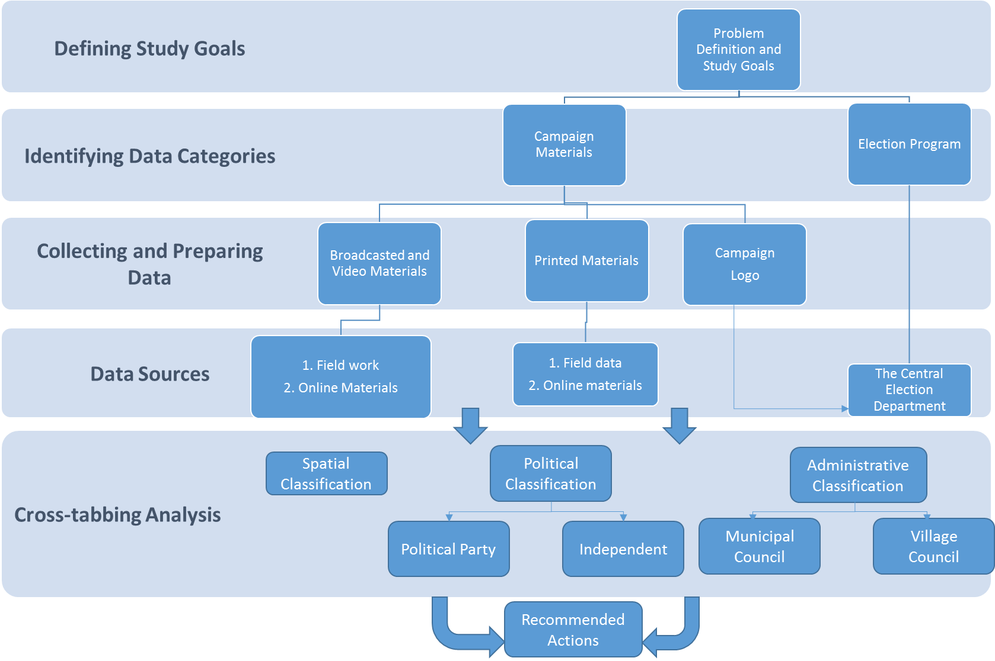
Figure (1): Study Methodology

All data sets were collected by the researcher from the official online websites and from Palestinian Central Elections Commission website and offices. Special forms were prepared to conduct a systematic review of the three types of election campaign materials. The election lists were classified into three classes that were selected specifically for their potential to have significant differences. The expected differences might lead to practical recommendations to improve the practices public involvement on the planning process.
The classes include: (1) according to the administrative level of the community whether it is a village council or a municipal council; (2) according to its political belonging whether the candidate belongs to a political party or independent; and (3) according to the governorate where the community is located.
3. Results and Discussion
The results indicate that 54% of the campaigns considers the community as a main partner in the decision making process. A lower percent (11%) indicates that the community is/will be a monitor on the municipality performance.
In general, the analysis of the election program show promising results as 89% of the programs include at least one aspect of the public participation. The political parties express higher interests in public participation (78%) than the independent candidates (48%). The other results are almost equal with no significant differences between municipal councils and village councils, and the governorates also have no significant differences.
The campaign logo analysis show also that the political parties express more interests in the participation. The results indicate that 63% of the political election-lists focus on the public participation while 33% of the independent lists don’t include any sign of the participation.
The printed materials show that 49% of the analyzed materials focus on the public participation and 51% don’t mention the participation. This percentage is almost evenly reflected on the three classes of the analysis with no significant differences among the municipal and village councils, political parties and independents, and among the governorates.
Finally, 46% of the broadcasted and video materials emphasize the public involvement and any related issues, while 64% neglect the public participation.
4. Recommendations
Referring to the results above, the study recommends to invest the relative high awareness of the election candidates through the following procedures:
1. New laws that motivate the decision makers to involve the public in the decision making process and developing new practical mechanisms to apply the relevant laws;
2. Design and implement training programs for the decision makers at the local level on the importance of the public participation and its role in the development process;
3. Design and implement awareness programs for the general public on their role on the planning process and their relevant rights; and
4. Design appropriate public participation tools that stem from the Palestinian context.
Finally, the study is an initiative to draw the researchers’ and the decision makers’ attention to the importance of the public participation issue in Palestine. This initiative can be developed and built on by other researchers to do more investigation on the role of the local leaders in adopting and implementing policies and strategies of public participation in the planning process.

